

Universal 2.30
Desktop Laser
Standard Operating Procedure (SOP) Manual

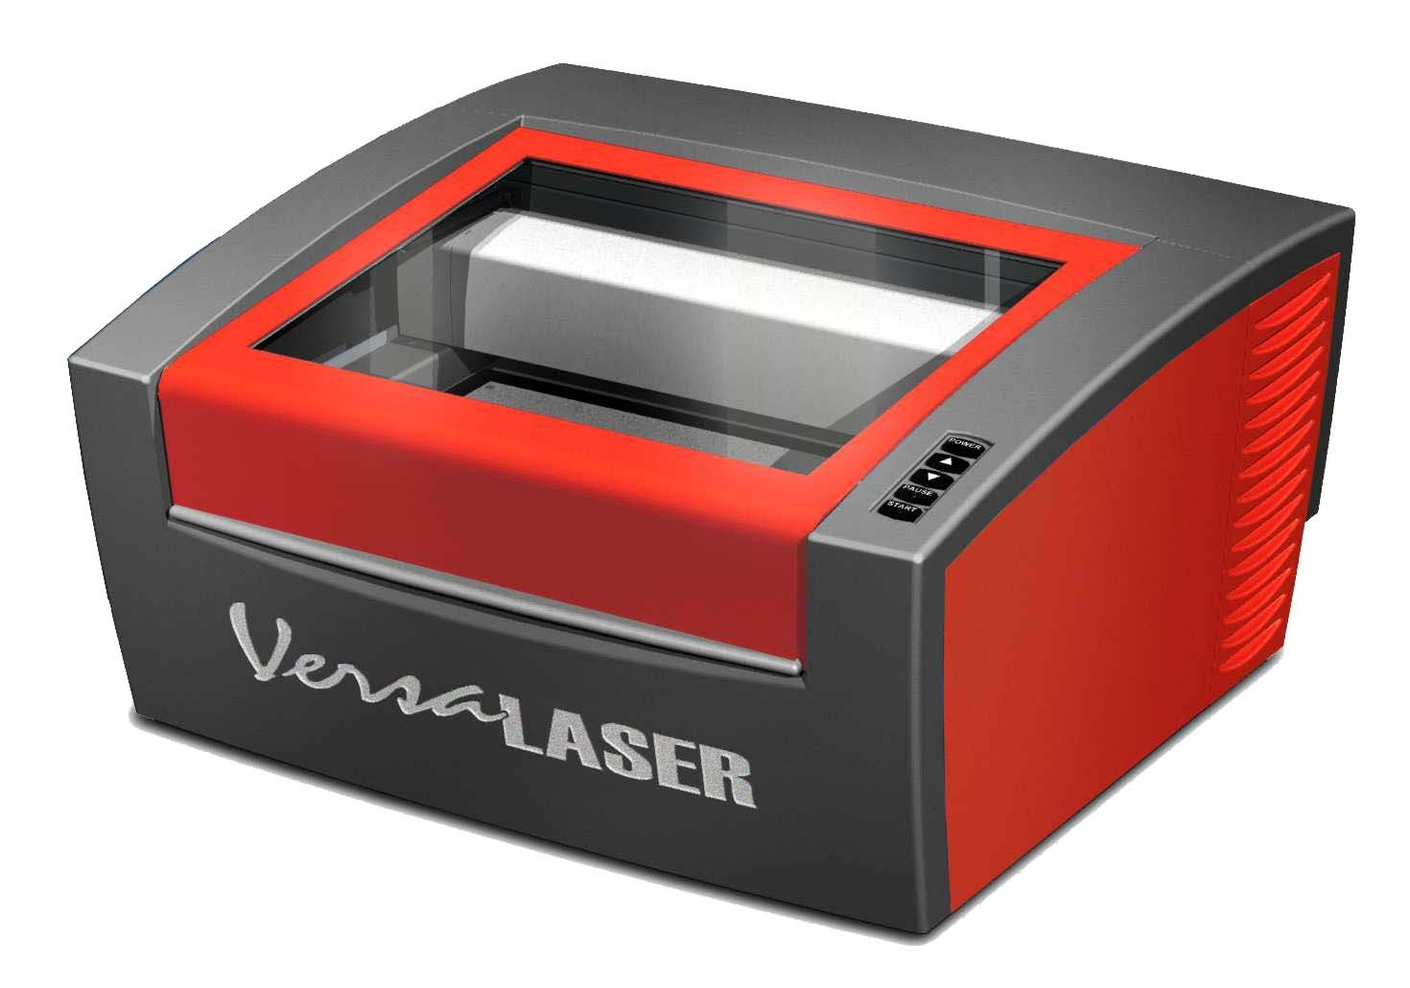
Training: Required
Reservation: Required

Please check with Library staff to confirm minimum age certification requirements to use this machine with supervision and without supervision.

Updated December 2022
Table of Contents (Page 1 of 2)
Certification & Reservations 4
Additional Resources & Online Training 4
Key Concepts (Lasers in General, Universal Laser Systems Specifically
Raster vs. Vector Basics) 5
Raster & Vector “Universal Laser” Modes (Cut, Mark, Engrave) 6
Materials—Approved, Banned & Minimum/Maximum Sizes 7
Training – Materials, Tools, Software, Learning Objectives, Workflow 8
Training Overview & Suggested Training Outline 9
Safety and Precautions 10
Machine Layout (Buttons & Permanently Installed Parts) 11
Machine Accessories—Fixtures to be Installed
Cutting Table, Engraving Table 12
Rotary Table (for Cylindrical Materials) 13
Operating the Digital Calipers to Measure Material 14
BOFA Air Filtration System 15
Laser System Control Buttons; X, Y, and Z Axes 16
Printer Driver Interface—Materials Database Tab 17-20
Materials Database; Red, Blue, Black, Gray; Category List 17
Materials List, Intensity, Thickness, Units, Fixture Type 18
Vector Performance, Merge Pages, Save, Load, Defaults 19
Cancel, Apply, OK, Rubber Stamp Processing 20
Universal Control Panel (UCP), Viewer Tab, Laser System Controls 21-24
Power, Up/Down Arrows, Pause 21
Start, Navigation Buttons, Home Buttons, Zoom Tool 22
Focus View, GO TO, Relocate View 23-24
Duplicate View, and Estimate Time View 24
Settings, File Management, Multi-Page Job Controls, System Status 25
Basic Steps for Most Projects 26-33
Getting Started, Opening CorelDraw, Using Pen Tool 26
Creating Cut Lines and Marked Lines, File, Print 27
Materials Database, Enter Measurements, Intensity Adjustments 28
Opening and Using Universal Control Panel 29
Determine/Install Table/Fixture, Using Focus Tool (if appropriate) 30-31
Place Material, Use Focus View, Ghost Cut & Relocate Tools 32
Close Lid, Turn on BOFA, Laser, Follow Closeout Procedures 33
Table of Contents (Page 2 of 2)
Closeout/Cleanup Procedures 33
Luggage Tag Example Using CorelDraw 34-38
Design elements, Cut & Mark Line requirements, Outline Tool 34
Draw Rectangles, Use Pick Tool, Align Elements 35
Set Size, Add Text, Draw Circle 36
Align Horizontally, Shape Tool/Round Corners, Set Cut/Mark Lines 37
Fill vs Stroke/Outline 38
Material Setup (Measuring and Loading your Material) 39
Removing the Cutting Table (and the Engraving Table) 40
View of Laser Cavity and Bottoms of both Tables 41
Installing the Engraving Table (and the Cutting Table) 42
Installing (and removing) the Rotary Fixture 43
Rotary Engraving—Design Considerations, Measuring/Loading Items 44
Rotary Engraving--Software Settings & Processing Cylindrical Piece 45-46
Troubleshooting 47
Positioning the Material 48
Lasering Glassware Guide 49
Selecting Glassware to Etch 50

For Makerspace Staff ONLY
Maintenance/Cleaning Method of Optics 51-53
Cooling Fan Filters and Cutting Table Maintenance 53
Maintenance Schedule/Additional Maintenance Information 54
Focusing the Laser Cutter 55-56
Manual Control Tab 57
System Tab 58-59
Diagnostics Tab 60-61
BOFA Filtration System—Changing Filters 61-62

Certification

To become certified on this piece of equipment you will need to attend a training class. More about the training’s learning objectives and outline can be found on Pages 8-9. To sign up for a training session please see makerspace staff for more information.

Reservation

To reserve this piece of equipment you will need to first be certified on this equipment by attending a training class. Check with makerspace staff related to reservation guidelines.

Additional Resources & Online Training:

Universal Manufacturers’ Manual for the 2.30 Laser Cutter can be accessed at: https://nlc.nebraska.gov/grants/InnovationStudios/Documents/vls_laser_cutter_manual.pdf

Universal 2.30 Desktop Laser Standard Operating Procedure (SOP) Manual at: https://nlc.nebraska.gov/grants/InnovationStudios/Documents/Universal%20Laser%20REV_A%20110617.pdf (an electronic version of this document)

Additional CorelDraw instructions may be accessed at:
https://nlc.nebraska.gov/grants/InnovationStudios/Documents/CorelDRAW_SOPrev08-15-18.pdf

1-Touch Laser Photo™ software (a Universal Laser Systems’ product) for converting digital photographs (BMP, JPEG, PNG or TIFF formats) into bitmap files can be used to indelibly mark or laser engrave the image into materials such as hard wood, stone or metal to create high value products. This transforms an ordinary photograph into a professional quality laser engraving. Although 1-Touch Laser Photo software is not covered in this document, it is installed on the four laser cutters in La Vista, McCook, Geneva and Randolph and perhaps other Universal Laser cutters depending on their original purchase packages. More information can be accessed at: https://www.ulsinc.com/discover-uls-innovations/1-touch-laser-photo

Box Maker Online Designs--The following link may come in handy as you seek to expand your laser skills. http://boxdesigner.connectionlab.org/

Online Universal 2.30 Laser Cutter Training--While the Library Innovation Studios project was active in Nebraska, an online training course for the Universal 2.30 Laser Cutter was created (along with trainings on other makerspace machines). Makers and trainers may access the courses at: https://my.nicheacademy.com/innovationtraining
Those who want to access the Library Innovation Studio lessons on Niche Academy must first create a free personal account with a login. To create an account you enter a first name, last name, and email address. Those that go through the entire lesson for any of the subject matters can print off a certificate of completion. Nebraska Library Commission staff will be able to view a list of those who completed the lessons, but will not be using or sharing email information.

Key Concepts

Lasers in General

Lasers use a tube of noble gases to generate a high intensity beam that can mark, engrave, and cut material. Similar to a pocket laser the beam can be quickly turned on and off, but the desktop laser uses a much more powerful beam and it is capable of varying the power applied to the laser, thereby controlling how much material is removed. For maximum control and clarity, the laser beam needs to be in a specific focus, which is affected by the material thickness.

Universal Laser Systems Specifically


All ULS laser systems are designed to operate like a computer printer. Laser systems are provided with two software components designed for Microsoft Windows based operating systems. The first component is a printer driver that allows you to print from any Windows based graphic software capable of printing through the Windows print system. This component shows up as a printer in the printer section of the Windows control panel. The second component is a task bar application called the Universal Control Panel (UCP) that controls and operates the laser system through the USB port. Laser systems cannot function unless this component is running on the PC connected to the laser system. This component shows up as a red diamond shaped icon in the task bar.

Printing through the printer driver creates a job for the laser system that is then transferred to and stored in the job queue in the UCP from which the job can be selected and run on the laser system as needed. The printer driver has a printing preferences interface. It can be accessed at the time of printing to set the laser system job settings for the particular job being printed. Most of these settings can also be changed after you select print in the design software through the UCP.

Raster vs. Vector Basics

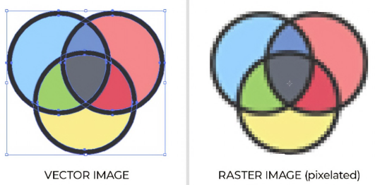
Two-dimensional images can be created using two different methods, either a raster or a vector. Raster images are composed of pixels and are capable of capturing a lot of detail; photographs are an example of raster images. Vector images are composed of perfect mathematical curves and can be infinitely scaled without a loss of quality, text in a text editor is an example of a vector image.

Laser cutters use both raster and vector images. In order to cut through a design a vector must be used for that cut line.

All lines created in CorelDraw are vector images. This does not include graphics that were found elsewhere and pasted into CorelDraw.

Raster & Vector Modes Related to Universal Laser Systems

ULS laser systems operate in one of two modes. A RASTER MODE in which images are etched/engraved into a material by etching a pattern of dots into the material at high resolutions up to 1000 dpi and a VECTOR MODE in which the laser follows a two dimensional path to cut and/or mark a shape into a material.

The printer driver determines whether an element in the graphic data being printed is a vector or raster object by its width.

Only lines and curves with a thickness of .001” (.0254 mm) or less will be interpreted as vector objects.

All other elements of the graphic being printed will be interpreted as raster objects.

Vector cutting depth, raster engraving depth, and marking intensity are controlled by specifying the speed of processing and the laser power level for raster engraving and by specifying the speed of processing, laser power level and number of pulses per inch (PPI) for vector cutting and marking. These parameters are automatically specified in the printer driver printing preferences interface.

Laser Cutting/Vector Cut
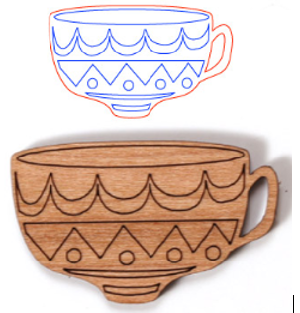
Objects to be vector cut must be in red and must have a thickness of .001” (.0254 mm) or less—or hairline.

Laser Marking/Vector Etching (Sometimes called “Score”)

Objects to be vector marked/scored must be in blue and must have a thickness of .001” (.0254 mm) or less—or hairline. Vector marking/scoring (sometimes called vector etching), creates a darker deep line. It is like a cut—but not as deep. The “teacup” image features both vector cuts, and vector marks.

Laser Engraving/Raster Engraving/Etching

Any vector elements in your graphic (other than those blue or red in color) will be converted to grayscale and engraved as raster objects. Therefore, both raster and vector images can be engraved into objects.

Whether cutting, marking/scoring, or engraving/etching, the laser head moves left and right rapidly and slowly moves down, similar to how a traditional inkjet printer works. The “order of execution” if you image has cut lines, marked lines and all other elements which are automatically converted to grayscale are:
- Raster and etched objects first,
- Then vector marking/scoring objects, and
- Finally vector cutting objects

Materials
Approved Materials:

Aluminum - Anodized
Aluminum - Markable
Cardboard
Cork Board
Fabric - Cotton
Fabric - Denim
Fabric – Felt
Glass - Lead Crystal
Glass - Soda-Lime
Glazed Tile
Granite
Laser Rubber
Laser Tile
Leather
Marble
Mat Board
MDF
Metal - Painted
Mother of Pearl
Mylar
Natural Woods
Nylon (6/6 & Ballistic Only)
Paper & Cardstock
Plastic - Acrylic
Plastic - Polypropylene
Plywood
Powder Coated Metal
Saltillo Tile
Silicone Rubber
Stone
Tackle Twill
Tool Foam
Vellum

Banned OR Permission Needed Material:
NEVER laser onto highly reflective surfaces to include mirrors. However, you may have seen mirrors that have been lasered. Mirrors can be lasered with the mirror side down (reverse the image since you view the design through the processed mirror. Lasering onto highly reflective surfaces is not only dangerous to those standing by the machine; it will also ruin the machine’s expensive optics—the mirrors and focus lens. Check with makerspace staff to see if mirrors are prohibited (because it is easy to forget to place the mirror in the laser mirror-side down).

Banned Materials (with Reason for Ban):
ABS | Emits cyanide gas and tends to melt—bad smell that lingers
“Bending” Plywood | It can easily bend into the lens carriage path during operation
Casting Wax | Melts
Corian | Creates a fine grit that will grind down equipment
Delrin | Emits Benzene which is known to cause cancer
Fiberglass | Contains Resins—likely to burn and blackens surfaces
Foamcore--polystyrene | Known to emit styrene fumes (those made with polystyrene)
Food | Makes a mess and can smell bad
FR4 Boards | Contains Resins—likely to burn and blackens surfaces
Highly Reflective | Lasering on highly reflective surfaces will ruin the laser’s optics
Lexan | Ruins the laser’s optics and causes the machine to corrode
Moleskin | May contain chlorine that emits a gas
Nylon | Emits toxic fumes
PETG, PET | Emits Benzene which is known to cause cancer
Polycarbonate (PC) | Emits black & yellow gas that makes you sick to your stomach
Polystyrene | Known to emit styrene fumes—which could cause cancer
PVC | Emits chlorine gas
Tropical Hardwoods | Many tropical hardwoods have toxins in the wood
Vinyl | Emits chlorine gas during a cut

Maximum Engraving Volume: 16” x 12” x 4”

Rotary Fixture Size Limitations:

Maximum Diameter: 5.5”
Minimum Diameter: 1.0”
Maximum Height: 9.5”
Minimum Height: 1.0”

Training – Materials, Tools, Software, Learning Objectives, Workflow

Materials and Tools/Accessories Used:

Universal 2.30 Desktop Laser
Focusing Tool
Digital Calipers Spray Bottle filled with Water

Piece of Birch Plywood Rotary Fixture
Cutting Table with Honeycomb mesh insert (Or Engraving Table—Solid Metal)

Software Used:
CorelDraw
Universal Control Panel (UCP)
Additional Software Note: 1-Touch Laser Photo software (not used in training, or covered in this document, however, it is often purchased and installed on Universal Laser Cutters (to include the laser cutters used in the Library Innovation Studios Project).

Learning Objectives of Training

Makers will learn how to:

Safely operate the Universal Desktop Laser
Avoid Issues that could harm the operator or the machine
Identify approved and banned materials for the Universal Desktop Laser
Identify machine layout and parts
Use the Standard Operating Procedures (SOP) manual to guide future making
Generate laser files
Adjust laser settings
Load material into the laser
Install the rotary fixture (and remove)
Install either the engraving or cutting table (and remove)
Execute a laser job that both engraves and cuts

Typical Project Workflow:

Design
Configure Laser Settings
Uninstall unwanted Fixture/Table (if applicable)
Install Desired Fixture/Table (if applicable)
Material Setup
Turn on Air Filter
Laser Material
Remove finished part(s) and waste material
Cleanup & Return Parts to their stored locations
Training Overview

This Standard Operating Procedure (SOP) manual contains more information than will be covered in training. Much of what the maker will eventually learn will be learned over many making sessions they will experience after being trained on the basics. This SOP and other information found online will help makers discover what they can do with other features in the software. A training outline for the Universal Laser Cutter using CorelDraw and the Universal Control Panel software follows. (This SOP and outline assumes that most trainees have had some previous training on CorelDraw.)

When instructors follow the training outline below using this SOP, makers will be provided the basics of the machine along with a full review of safety concerns. Allow time to get through a simple design project from start to finish with hands-on learning opportunities using the Cutting Table. A rotary fixture project is also recommended to reinforce the use of both CorelDraw and the Universal Control Panel software.

Suggested Training Outline
 |  |  | Page Numbers
 | Welcome, Review Training Objectives |  | 8
 | Key Concepts in a Nutshell
 |  | Laser Cutters, Raster vs. Vector Basics | 5
 |  | Engraving/Etching, Cutting, Marking | 6
 | Machine Parts & Buttons
 |  | Machine Layout--Parts & Buttons | 11 & 16
 | Accessories & Fixtures/Tables
 |  | Two Tables & Rotary Fixture—When to Use Each | 12 & 13
 |  | Calipers--How to Use & Measure Material | 14
 |  | BOFA Filtration System and its Warning Lights | 15
 | Materials Approved & Banned & Minimum/Maximum Sizes |  | 7
 | Safety and Precautions--Review Each One |  | 10
 | Universal Control Panel--Control Buttons |  | 21-24
 | Basic Steps for Most Project--Let's Do a Project |  | 26-33
 | (Can do the Luggage Tag Example or Alternate Design) |  | Still start on 26
 | Activities to do during the Basic Steps Section or Prior
 |  | Remove a Table; Install a Table | 40-42
 | Rotary Fixture Project
 |  | Install & Remove Rotary Fixture | 43
 |  | Designing for Rotary, Lasering Jar or Glass | 44-46
 |  | Measuring Jar or Glass, Loading Glass | 44
 | Invite New Makers to Continue their Learning Process:
 |  | Show Table of Contents--More Features to Learn | 2-3
 |  | Show List of Resources for Continued Learning | 4
Safety and Precautions
- The Maker must remain present with the machine during all laser operations, if an operator needs to leave the area, the job should be “paused.”
- Filter the smoke/fumes by ensuring the BOFA filtration system is turned on before you engage the laser. Leave the BOFA on 15 seconds after lasering is complete.
- An intense laser light appears during the engraving and cutting process. DO NOT stare at this intense light for long periods of time or view directly with optical instruments of any kind. Doing so could damage your eyes.
- The device contains a visible Red Diode Pointer (Class 3R) to aid in positioning material. DO NOT look directly into the red beam or use a reflective surface to redirect or view the beam. Never view the beam using optical instruments.
- The laser cutter’s lid/door is safety interlocked which will prevent the CO2 laser beam from firing when the machine’s door is open. However, the Red Diode Pointer can be activated when the lid/door is open.
- If the machine is not set up correctly, material may ignite or smolder. In the event of a small fire (nearing the size of a quarter), follow these steps until the fire is contained:
  - Stop the laser by lifting the machine’s lid (which stops the laser)
  - If that did not work, smother the fire by placing a piece of wood over the fire
  - If that did not solve the issue, spray the flame using the water spray bottle.
  - If the fire persists, close the lid, press “pause,” and call makerspace staff. They might use the electronic-safe fire extinguisher or call 911.
- Only one table or rotary fixture should be in the machine at a time, stacking tables would result in incorrect focus height that could damage the machine.
- An incorrect thickness/height measurement can result in wedging objects between the table and the laser head. Use a caliper to measure and write down the measurement. Make sure when you measure in metrics or inches to enter that measurement in that same unit of measurement.
- Never touch any of the optic surfaces with your hands as oils can damage the optic’s coatings. Note that the optics can be easily scratched and ruined. Staff who clean the optic parts—mirrors, focus lens, and beam window—should follow all precautionary instructions related to the handling, inspection and cleaning of those surfaces in the “Makerspace Staff” section.
- Unapproved materials should never be lasered as they may emit toxic and corrosive fumes. If you are unsure which materials are banned and should not be lasered, review the banned materials on Page 7. Do not mistake banned plastics for acrylic.
- Do not laser on highly reflective surfaces with the reflective side face up as you could damage your eyes and it will ruin the expensive focus lens. Mirrors can be lasered on the back (mirror-side down) if allowed and checked by makerspace staff.
- Never leave materials in the machine after laser processing has finished. Always remove all materials to include scrap material. Materials left in the machine including pieces caught in the meshed cutting table, can be a fire hazard.

Machine Layout – Buttons & Permanently Installed Parts
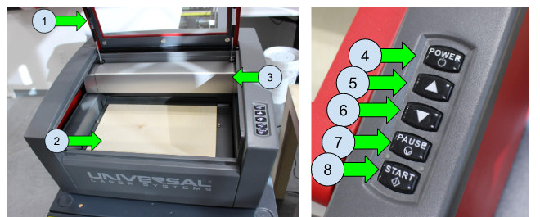

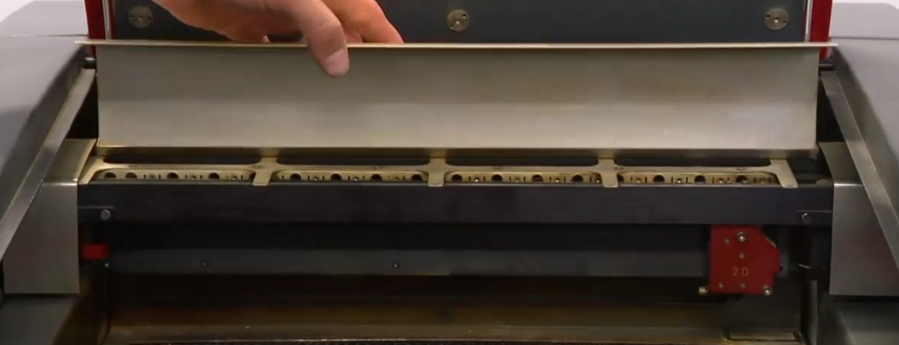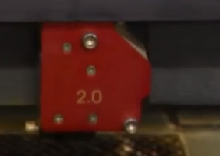
11
12
13
14B
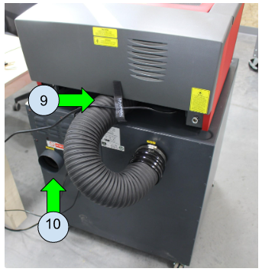
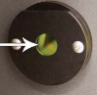
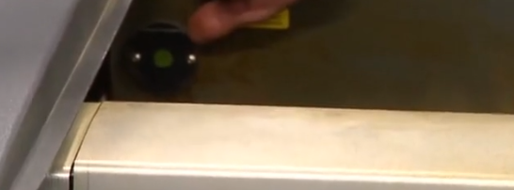
Back of Universal Laser Cutter
15
- Lid/Door of Machine
- Cutting Area
- Gantry/Arm
Back of BOFA Filtration System
- Power Button
- Raise Bed Button
- Lower Bed Button
- Pause Job/Resume Job
- Start Job
- Untreated Exhaust Port
- Clean Exhaust Port
- Handle of Hidden Mirror (laser beam moves from beam window to handled mirror)
- X-Axis Rail (the Horizontal Axis)
- Focus Lens & Mirror Assembly (laser beam moves from handled mirror to mirror then focus lens, both located in this lens/mirror assembly)
- X-Axis Rail Cover—shown open
- Beam Window—where beam enters laser cavity (behind left side of Gantry)

Machine Accessories--Fixtures to be Installed (Install Only One)

Depending on what you will be cutting or engraving, you have three choices of which floor/unit to install into the laser machine. These include the Cutting Table (with honeycomb mesh design), the Engraving Table (solid metal), and the Rotary Fixture. Note that you can only have one of these units installed in the machine at any one time.

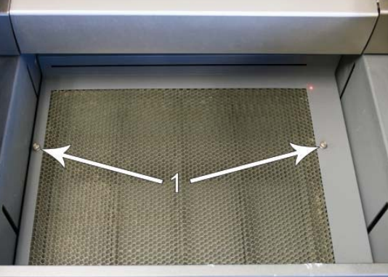
Cutting Table

The cutting table with the honeycomb mesh design is used to support material when cutting so that exhaust flow is redirected both above and below the material for clean cuts. Without it, smoke and debris can build up underneath the material causing the surface of the material to be damaged. The cutting table also helps to reduce damage to the surface of the material from laser back reflection that can occur when you are using the solid metal engraving table instead of the cutting table.
Cutting Table w/honeycomb design featuring two thumbscrews (marked 1) that can be used to “lift” the table in and out.

If your work piece is a flat surface that will also include cuts through the material, this is the table to install and use. Because of the delicate honeycomb floor, you will also want to avoid placing heavy objects on this surface. Place any material on the honeycomb in a gentle fashion so you do not damage the honeycomb mesh.
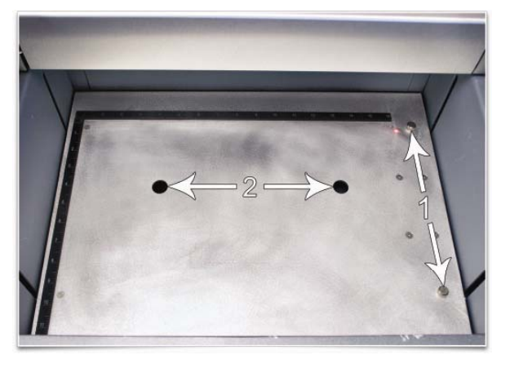
Engraving Table

Use the solid metal Engraving Table for those flat surface projects that you are only engraving and not “cutting” entirely through your material. Although you can use the mesh table when only engraving, the solid metal Engraving Table is thinner so you have more clearance in the machine’s cavity and the Engraving Table is sturdier for those heavier materials you may be engraving.
Engraving Table w/solid metal design featuring two thumbscrews (marked 1) and two finger holes (marked 2) that is used to lift or lower the table in place.

Note: Refer to Pages 40-42 for Removal and Installation Instructions for Tables.
Rotary Fixture
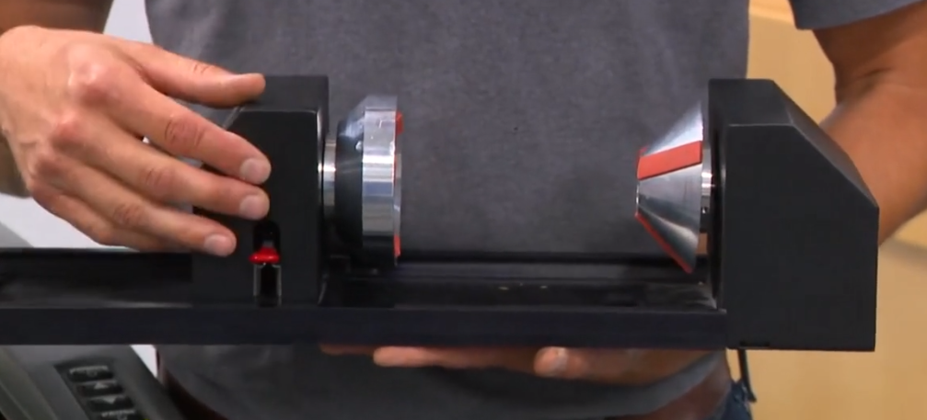
The Rotary Fixture allows the laser system to engrave and mark on cylindrical objects. You can laser on items that are between 1 inch to 9.5 inches in height and between 1 inch and 5.5 inches in diameter (refer to Pages 49-50 as to other glassware considerations). The Rotary fixture is equipped with an external cone-shaped fixture mounted to the fixed, motorized end and a concave-shaped fixture attached to the adjustable end allowing the fixture to hold a variety of objects such as wine glasses, mugs, carafes, bottles, etc.
Rotary Fixture Parts Cone Shaped fixture on Motorized End
Lever that Locks/Unlocks Adjustable End Adjustable Concaved End

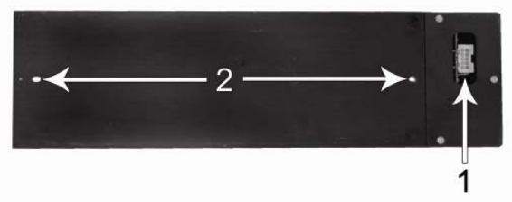
View from Bottom of Rotary Fixture featuring self-aligning electrical connector (marked 1) and two alignment holes (marked 2)
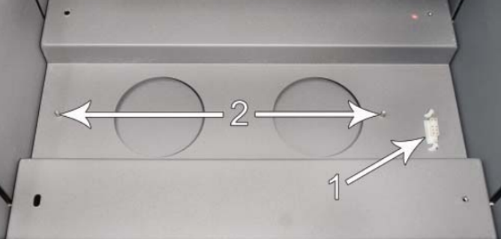
View inside of Laser Machine featuring an electrical connector (marked 1) and two protruding alignment pins that will match up with the rotary fixture’s alignment holes.

Note: Refer to Page 43 for Rotary Fixture Removal and Installation Instructions.
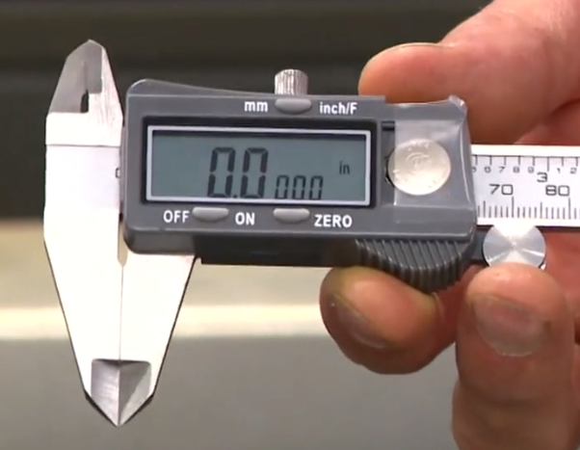
Operating the Digital Calipers to Measure Material
In order for the laser cutter to focus the beam of light onto the work surface properly, it will need to position itself at a precise distance from the top of the work piece. Therefore, a “precise” thickness or height of the material that will be engraved/cut must be entered into the software. To get that precise measurement, always use digital calipers to determine the thickness/height. NEVER depend on the labeled thickness of materials. NOTE: For cylindrical shaped items that will be engraved using the rotary fixture, measure the diameter of the item rather than its height.

Digital calipers feature several buttons on the digital calipers as follows:
Off/On button
Zero button
Units button (to change from metric units (mm) to decimal units (inches)

Before you measure, start by making sure the jaws of the calipers are fully closed. If the calipers do not read 0.000, you can push the Zero button to recalibrate the device.
NOTE: If the digital calipers are not working, try replacing the button battery inside.

Close the jaws around the material you will be etching to find the thickness/height to enter into the software (diameter if using the Rotary Fixture). See images below.
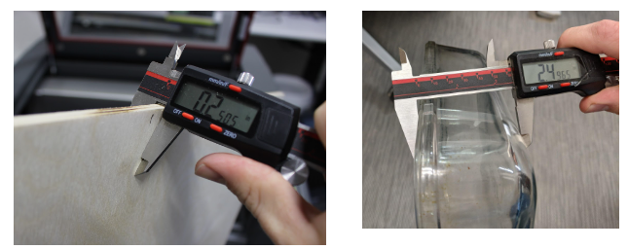 |  | 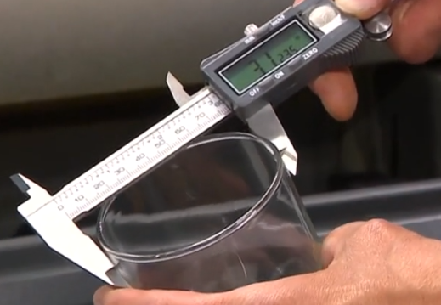
Measuring Board for Engraving or Cutting Table | Measuring Height of Casserole Dish (engrave bottom up) or Box (engrave top) for Engraving Table | Measuring Diameter for Rotary Fixture
Once you determine the measurement, write that measurement down exactly as it is indicated on the calipers noting the units of measurement (metric or inches) so that you can enter that exact measurement along with the correct units of measurement into the UCP software in a later step.

Although when using the digital calipers to measure materials for the laser cutter you will be placing the material between the calipers’ jaws, for applications beyond the laser cutter there are two other areas of the calipers that measure. The Upper Jaws can be used to find inside measurements, and the Depth Rod that pops out the back can be used to measure inside depths of items.
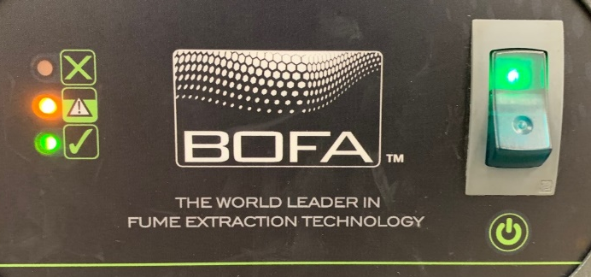
BOFA Air Filtration System

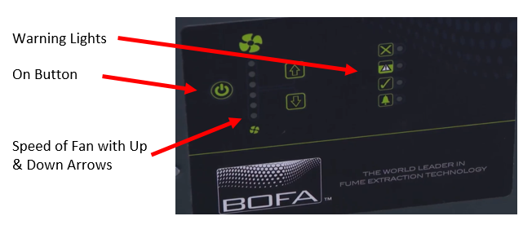
There are several brands and models of filtration systems that can be connected to laser cutters. The pictures to the right show the front panels of BOFA Filtration models AD Base C180 and AD-350. Each of these models have two internal filters made specifically to fit those machines—the Pre Filter, and the Combined Filter.

Never operate the laser cutter without first turning on the filtration system (unless you are venting your laser cutter outside). If you forget to turn on the filtration system, smoke will begin to fill the laser cutter—this will mess with the optics operating properly and the room’s air quality.

Some filtration systems have a fan airflow indicator with up/down arrows. You cannot simply move the arrows up or down without following the manufacturers’ instructions on how to set airflow. Generally, once set, the airflow does not need further adjustments.
Important Information to Know about the Colored Warning Lights:
Green: Filter is Operating Correctly
Yellow: Filter is Filling Up, Inform Staff so they can purchase new filters
Red: Filter is Full, Do Not Use Laser and Inform Staff to change filter(s)

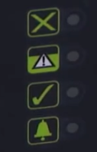
There will be three or four warning lights on BOFA systems:

The “X” light will indicate whether the system if “Blocked” or not.
The “Triangle !” light indicates how full the fuller of the two filters are.
The “Checkmark” light will indicate how your machine in running
The “Bell” light is the Alarm (not all machines have this indicator).
Links to Manufacturers’ Instructions for two BOFA filtration systems (as well as tips gathered by Library Innovation Studios’ staff) follow:
http://nlc.nebraska.gov/grants/InnovationStudios/Documents/AD350_Instruction_Manual.pdf
http://nlc.nebraska.gov/grants/InnovationStudios/Documents/AD-C180_Base_Instruction_Manual.pdf
http://nlc.nebraska.gov/grants/InnovationStudios/Components/Tips_For_BOFA_Indicator_Lights_&_Replacing_Filters.pdf

Laser System Controls (Buttons on the Machine)—What Do They Do?
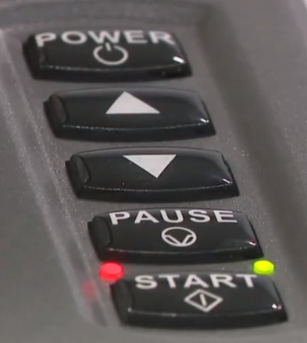
NOTE: The buttons on the machine are also available in the Universal Control Panel (UCP) software on the computer.

POWER – The Power button powers the machine ON and OFF, but only if the laser is connected to the computer and the Universal Control Panel (UCP) software is running in the task bar on the computer. To power the Laser System OFF, the power switch must be held down for about five seconds.

UP/DOWN ARROWS – The Up and Down Arrows moves the Engraving or Cutting Table up or down for loading material into the machine and focusing. Pressing an arrow button once will move the table .010 inches in the indicated direction. Holding an arrow button down will move the table continuously in that direction until the button is released.

PAUSE – The Pause button allows you to pause the engraving/cutting process if you need to walk away from the machine or if a flame begins to develop. (The focus carriage will move to its home position in the upper right hand corner of the engraving area.) Hitting PAUSE again will resume where you left off. DO NOT resume by pressing START as the job will start at the beginning of the file and not where it left off.

START – The Start button begins processing the selected job (and visible in the preview screen on the UCP) from the start of the file. If you pause the machine and return—make sure to press pause again—rather than Start, so you resume where you left off rather than starting over.

RED LIGHT ON – The top door to the laser system is closed. If a laser job is initiated in this state, the CO2 laser will fire.

RED LIGHT FLASHING – The top door to the laser system is open and the safety interlock system has disabled the CO2 laser. If a laser job is initiated in this state, the CO2 laser will not fire and the red Diode pointer will be initiated instead.

GREEN LIGHT ON – A “lit” Green LED light indicates that the machine is powered on.

NO LIGHTS ON – If no lights are on, the machine is powered off.
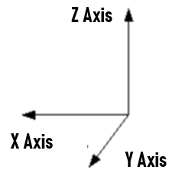

X, Y, and Z Axes References

There are references throughout this manual and during training regarding the X Axis, Z Axis and sometimes the Y Axis. The Focus Lens/Mirror Assembly moves from right to left horizontally on the X Axis. The Gantry moves forwards and backwards in the machine on the Y Axis. (You cannot manually demonstrate this forward/backwards movement unless the machine is turned off.) The floor of the machine moves up and down on the Z Axis. The up and down arrow on the machine moves the floor up and down on the Z Axis.
The Printer Driver Interface

The printer driver is a piece of software that allows you to create jobs for the laser system using the Windows print system. The printer driver has a preferences dialog with two tabs which allow you to set various parameters for a print job. One is the Materials Database tab that is summarized below. The other tab is the Manual Control Tab that is sometimes used by advanced users. There is limited information about that tab on Page 57.

Materials Database (Printer Driver) Tab

This tab of the printer driver automatically calculates the appropriate “nominal” laser job settings based on the material selected and the maximum output power of the laser installed. There are only three sets of job settings available, one for each type of graphic element that might make up your print job: raster “engraving” objects, vector “cut” objects and vector “mark” objects.

GRAY VS. BLACK—All elements of the graphic interpreted as raster objects will be converted to grayscale and printed using the raster job settings with a grayscale dither pattern applied. A dither pattern is a method of mimicking shades of gray using patterns of dots with varying spacing. Dots further apart will appear lighter gray and dots closer together will appear darker gray. This is how the laser system is able to print shaded images and photographs. If you desire a solid background for your graphic instead of a dither pattern, you must make those elements solid black in color.
Objects to be vector cut must be in red and must have a thickness of .001” (.0254 mm) or less.

Objects to be vector marked (or scored) must be in blue and must have a thickness of .001” (.0254 mm) or less. Vector marked sometimes called vector etching, creates a darker deep line. It is like a cut—but not as deep. The “teacup” image features both vector cuts, and vector marks.

Any vector elements in your graphic that are not blue or red in color will be converted to grayscale and printed/engraved as raster objects. If you design a solid background such as inside text, make those elements solid black.

The order of execution when using the materials database tab proceeds with engraving the black/grayscale objects first, then vector marking objects and finally vector cutting objects.

Controls in the Materials Database Printer Drive Tab Described Below:

Category List (Under Materials Tab)

This section allows you to choose a material category. These include: Ceramic, Fabric, Foam, Glass, Metal, Natural, Plastic, and Rubber. Therefore, if your material is wood, you would start with the “Natural” category to find the type of wood you will be using.
Material Database List

Once you select a category, a variety of material types will appear to the right of the category section from which to choose. You will be selecting the material that will match the material that you will be engraving/cutting. If you are using Birch wood, first select “Natural,” then “Wood” then Medium Wood—Birch. If you are inserting a glass jar, select “Glass” then “Soda-Lime Glass.”

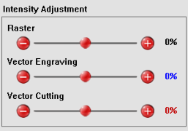
Intensity Adjustments

Intensity Adjustments allows you to adjust the nominal material settings for raster, vector mark (thin blue lines) and vector cut (thin red lines) operations up to +/-50%. Increasing the intensity gives you deeper results. Decreasing the intensity gives you shallower results. Always start at zero on a scrap piece of material and make any necessary changes after a trial run.

Material Thickness

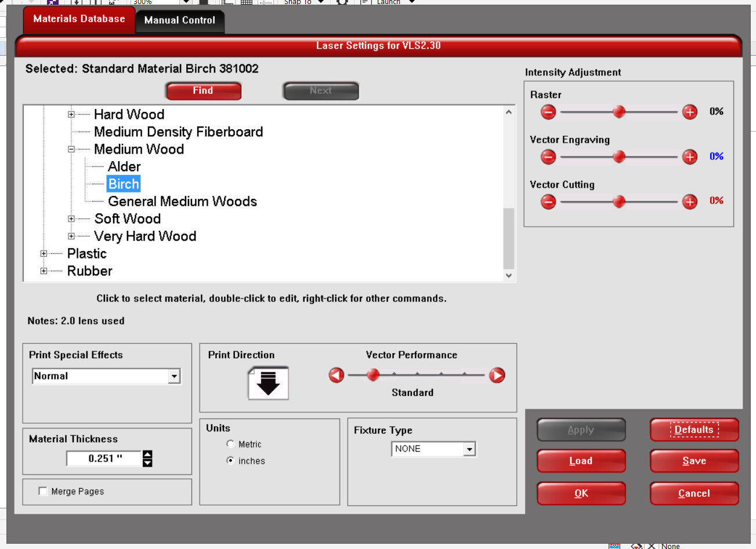
You must enter the thickness of the material to be processed (how high it will be when it sits off the inserted table). This value is used by the materials database to calculate the vector cutting job settings to ensure that the laser cuts all the way through the material. This value is also used to by the laser system to move the Z-axis to the proper focus height when using the auto Z mode. Always use digital calipers to measure the thickness (height) of your material and enter it into the Material Thickness box (refer to Page 14). Make sure that in the Units area that you indicate the same units you used when you measured using the calipers.

Units

This section allows you to switch between Metric and English units. Make sure you use the same units you used when you measured using the calipers.

Fixture Type

Here you select the fixture that you have installed into the machine that you will be using for the job—None, the Rotary Fixture, or the Custom Table (the Cutting (honeycomb mesh) Table or the Engraving Table (solid metal).

Rotary—If you are etching the sides of a cylindrical item such as a jar, you will be installing the Rotary Fixture.

Custom (Cutting Table) --This setting is used to set the height offset from the engraving table of any fixtures such as the cutting table or any custom fixtures you might use to support the material to be processed. This value is used along with the material thickness to move the Z-axis to the proper focus height when using the auto Z mode.
Vector Performance

This setting allows you to adjust vector performance from Standard to Throughput or Quality. This effects how small geometry and curves in your graphic are processed. The Quality mode will increase job completion time, but improve vector quality. Throughput mode will decrease job completion time, but may have an adverse effect on vector quality. Click on the left arrow to improve the quality. Click the right arrow to increase the speed of the vector lines at the cost of quality and accuracy. An example of when you might want to increase the speed as the cost of quality is when you are cutting foam for packing where the quality does not necessarily matter.

Merge Pages

By default, multipage documents are treated as separate jobs with each page having to be selected in the UCP and run individually. However, selecting this setting once will merge the pages with auto-start, meaning the pages will all be printed one after another as one job. This is useful if you want all the graphic images to print on one piece of material, but you want to control the order in which they are applied. Selecting this setting again will merge the pages with manual start, meaning the pages will all be printed one after another as one job, but with the laser system pausing in between each page. This is useful if you need to load new material in between each page.

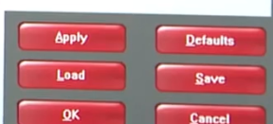
Save Button

The Save button brings up a dialog box that allows you to save a snapshot of the laser job settings that you can then reload at a later date. All settings will be stored in a file with “.LAS” extension. However, keep in mind that another user could delete any stored files. (See the Load Button below to retrieve saved files.) This could be useful if you want to recapture a great look you discovered later.

Load Button

To recall a snapshot of the printer driver settings that have been previously saved to a .LAS file using the save button, select the “Load” button and choose the desired .LAS settings file from the dialog box. The settings that are currently on screen will be replaced by the settings from the .LAS file. You may abort these changes by selecting Cancel; selecting OK or APPLY will approve the changes.

Defaults Button

The Defaults button will reset the driver settings to factory default values. You may abort these changes by selecting Cancel; selecting OK or APPLY will approve the changes.

Cancel Button

The Cancel button closes the printer driver settings interface window and takes you back to the previous window without saving changes made to the settings.
Apply Button

The APPLY button saves all changes made to the printer driver settings. If you made changes, you must hit “Apply” before you hit “OK.”

OK Button

The OK button saves all changes made to the printer driver but you first need to Click on APPLY then OK. Hitting OK closes the printer driver settings interface window and takes you back to the previous window.

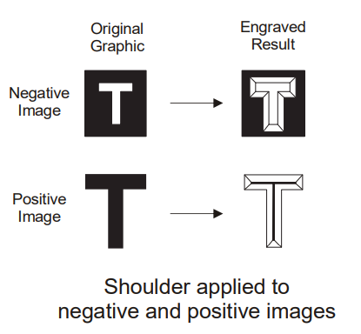
Rubber Stamp Processing

The rubber stamp material in the materials database activates a special shouldering mode. This mode is specifically for rubber stamp creation and is used for creating shoulders on characters and graphics when processing rubber stamps. The shoulder is created by gradually ramping the laser power up or down near the edges of each element in the graphic being printed creating a tapered edge around each graphic element that produces a pyramid-like effect in the material being processed. Most rubber stamp applications will require the graphic to be a negative image with black representing the material to be removed by the laser.

The Universal Control Panel (UCP) Software


When a graphic has been printed through the printer driver, a laser job is created and passed to the queue in a piece of software called the Universal Control Panel (UCP). The UCP software provides a convenient interface for interacting with and controlling your laser system. To indicate that the UCP software is installed on your computer, a red diamond-shaped icon will appear in the lower right corner of your Windows taskbar. If for any reason the UCP is deactivated, you can reactivate it by using the ULS Engraver shortcut found on your computer’s desktop. The UCP is organized into three tabs: Viewer, System and Diagnostics. The Viewer tab is covered below through Page 24. The System Tab and Diagnostics Tab are covered in the Makerspace Staff section on Pages 58-61.
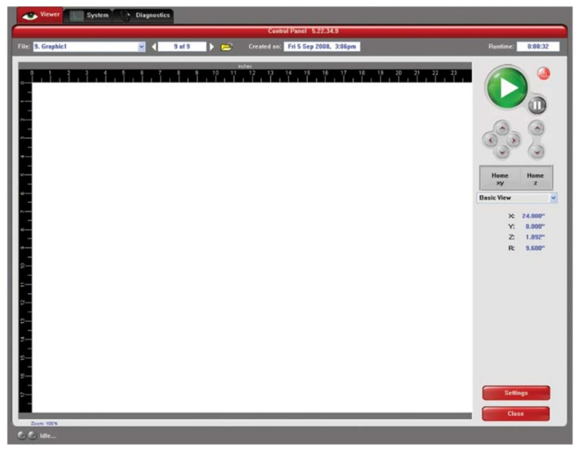

Viewer Tab

You send jobs to your laser system by printing to it. Anytime you print to the laser system, a job is created and inserted into the laser systems job queue. Selecting the viewer tab allows you to navigate through and manage the jobs in the laser system job queue. The viewer tab also allows you to operate your laser system right from your computer. The viewer tab has the following functions:

Laser System Controls

The same controls found on the laser machine are duplicated here in the “Viewer Tab” (plus there are additional buttons here, not found on the laser machine itself).

POWER – The Power button powers the machine ON and OFF, but only if the Laser system is connected to the computer and the Universal Control Panel (UCP) software is running in the task bar on the computer. IMPORTANT NOTE: To power the Laser System OFF, the power switch must be held down for about five seconds.
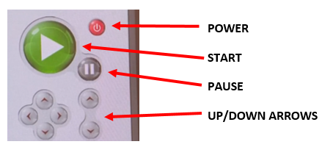
UP/DOWN ARROWS – The Up and Down Arrows moves the Engraving or Cutting Table up or down for loading material into the machine and focusing. Pressing a button once will move the table .010 inches in the indicated direction. Holding an arrow button down will move the table continuously in the indicated direction until the button is released.

PAUSE – The Pause button allows you to pause the engraving/cutting process if you need to walk away from the machine or if a flame begins to develop. (The focus carriage will move to its home position in the upper right hand corner of the engraving area.) Hitting Pause again will resume where you left off. DO NOT resume by pressing START as the job will start at the beginning of the file and not where it left off.

START – The Start button begins processing the selected job (and visible in the preview screen on the UCP) from the start of the file. If you pause the machine and return—make sure to press pause again—rather than Start so you resume where you left off rather than starting over.

NOTE: The Up/Down Arrows, Pause, and Start can be used either on the machine or in the UCP software from the computer itself.

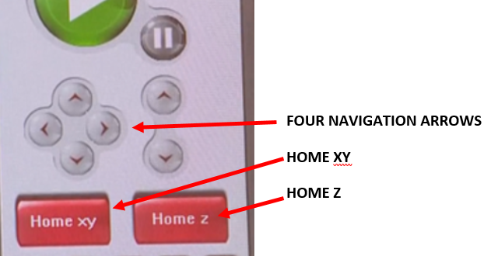
FOUR NAVIGATION BUTTONS – The four navigation buttons move the focus carriage Right and Left in the X Axis and Forward and Back in the Y Axis.

HOME XY – The Home XY button re-homes the focus carriage to the upper right hand corner of the field.

HOME Z – The Home Z button re-homes the Z-Axis table to the bottom of the laser system. (Note—on Startup these two home positions are engaged automatically)

View Tab Modes

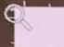
A drop down list allows you to select from various modes of operation for the preview screen. The preview screen shows the graphics related to the job you brought in from CorelDraw or another design software. The “Basic View” is the default mode in the drop down list. The Basic View shows a preview window of the job currently selected.

The cursor becomes a magnifying glass (Zoom Tool) if you pass it over the preview window so you can see fine features of your design. Left clicking the mouse zooms in and right clicking zooms out.

Selecting the Settings button near the bottom right, takes you back to the printer driver interface to allow you to change most of the settings for the job selected. Keep in mind that some settings cannot be changed after printing from your graphics program such as print density and vector quality. If a setting is not adjustable after clicking on “Print” in CorelDraw, it will be grayed out or not appear at all when you press the settings button in the UCP.
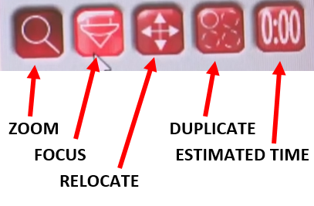
Other Tools in the Viewer Tab

A summary of the other tools in the viewer tab (identified in the graphic to the right) are reviewed on the next two pages.
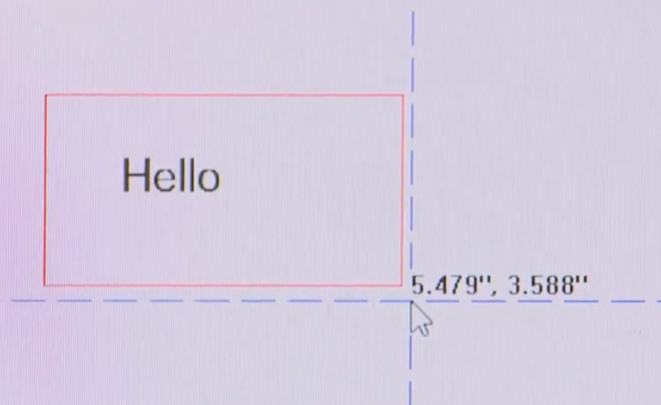
Focus View (drop down list)
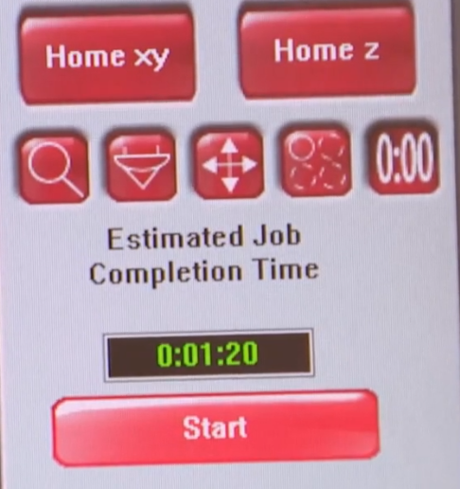

The Focus View allows you to easily move the focus carriage to a desired position in the material processing field.

• To have full range of motion, verify that you are zoomed out in the preview window by right clicking on the mouse before entering the manual focus window.
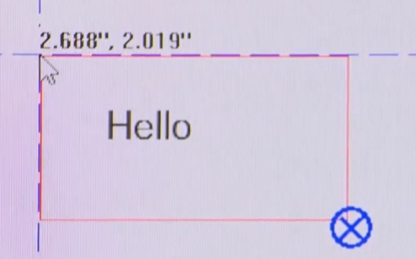
• In the focus view, the cursor changes to a blue target symbol  with trailing X-Y coordinates. Clicking the mouse in the preview window moves the focus carriage to the selected position. If your machine’s lid is open, you will see the Red Diode dot shining down on your material. NOTE: Selecting another feature from the drop down list terminates the focus feature and moves the focus carriage back to the home position. NOTE: Once you know where you want your graphic, follow the instructions in the “Relocate View” section below.

• GO TO button--Or if you wanted to move the focus carriage to a specific location, select the GO button. Type in the X and Y coordinates and press the GO TO button and the focus carriage will move to the specified location. You can also move the engraving table to a specific Z-height using the GO feature.

Relocate View (drop down list)

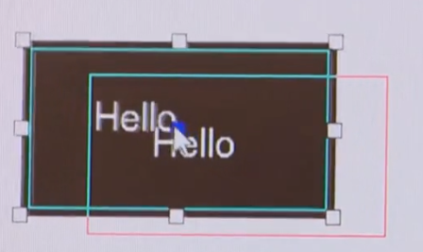
The Relocate feature gives you the ability to move the image in the selected job to another area of the engraving field. This feature does not permanently modify the original image location.

When this feature is activated, the image is surrounded by nine small squares (anchor points) representing the boundaries of the graphic. You can relocate the image using these anchors in one of three ways:

1. You can select and hold an anchor point and drag that anchor to move the image around in the field.

2. You can select an anchor point and type a new X-Y coordinate for that anchor point in the X-Y fields to the right of the preview screen.

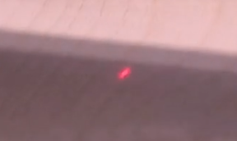
3. Using the X-Y manual motion buttons, you can move the focus carriage to a location on the processing table in the laser system using the red pointer diode as reference, then select an anchor point in your image and press the TO POINTER button to move that anchor point to the current focus carriage location. This feature is useful for aligning an image with a piece of material you plan to process with the laser system. (This is also described on Page 32.)

Duplicate View (drop down list)

The Duplicate feature gives you the ability duplicate an image in a grid pattern. When you increase the quantity in the X Axis (horizontal axis), you are adding more copies in that row. When you increase the quantity in the Y Axis (vertical axis), you are adding copies in a column. You can select how many rows and columns of the image as well as the spacing (displacement) between the rows and columns. After you create a grid of duplicate images, you can also remove any one of the copies or the original from the group by selecting that instance in the preview window. If you need to restore a copy that you removed, click in the general area of that instance and it will return. To get the duplicates pictured below, set the quantity in the X box to 3 and the Y box to 3. If you were making nametags, you would first duplicate the first nametag you designed, and then you would go in and change the text in each box to a different name.

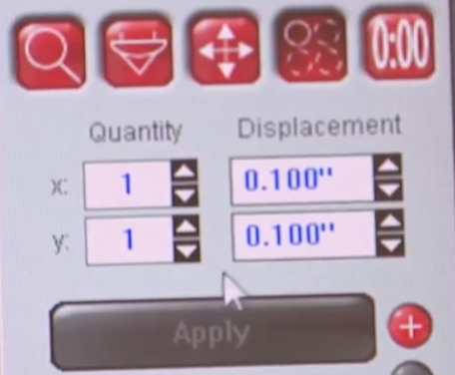 | 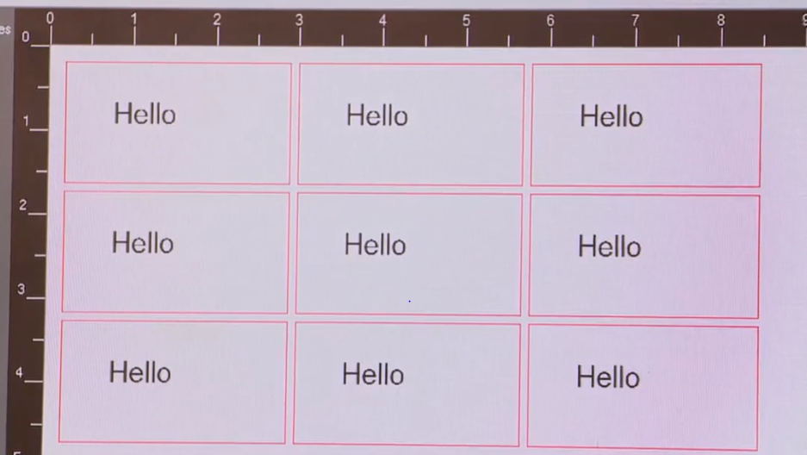

Estimate View (drop down list)

The estimate feature approximately calculates the amount of time it will take the laser system to process the selected job. For more complex jobs, it can take a while to estimate the job’s completion time.

Settings
Clicking on the Settings Button (located in the lower right hand corner of the Universal Control Panel (UCP) screen gives you access to the Materials Database Printer Driver settings for the selected job. The Materials Database Printer Driver tab is covered on Pages 17-20. Any changes made will be permanently saved with the job.

File Management As jobs are printed, they are added to the print queue until the queue reaches the print queue limit set in the system tab. Once the Print queue reaches the maximum number of jobs, the printer driver deletes the oldest job each time a new job enters the queue. Information listed above the preview screen includes the name of the currently selected job, the number of jobs stored, the date and time the selected job was stored on the hard drive and the job processing time (after the job has been run once). Just under the name of the job the Copies feature tells you how many times the selected job has been run on the laser system. Navigation Arrows on either side of the currently selected print job number allow you to navigate through the print jobs stored on the hard drive. The “folder” button displays a pop up window that allows you to manage the jobs in the print queue by performing such functions as: importing print jobs exported from other computers, exporting print jobs, deleting print jobs, marking jobs as permanent so they will not be deleted by the system, and purging the entire queue (except for jobs marked permanent). Keep in mind that other makerspace users could delete past files so if you really need to have access to a past file, safe it to a thumb drive or cloud service.

Multi-page Job Controls

If you print a job from a graphics program that supports creation and printing of multi-page documents, a second set of file navigation controls will appear below the preview windows allowing you to navigate through the pages in the multi-page job. Multi-page jobs can by processed with each page manually selected in the preview screen one at a time or they can be merged and processed as a single job with or without a forced pause between pages. Use the multi-page control in the printer driver (setup button in the UCP) to control this.

Laser System Status Indicators

At the bottom left of the preview window, two lights and some text are provided to indicate status of the laser system connected to the UCP. Blinking of the lights indicate when the UCP is talking to the laser system and the status text indicates the current state of the laser system.

Basic Steps for Most Projects

- Make sure the computer paired with the laser cutter is turned on.

- Open the lid on the laser cutter. Turn on the laser cutter. (You can choose to turn on the laser cutter after your design is complete.)

- You can draw an image in CorelDraw, or you can go to the Internet and choose your image (or insert your image from a flash drive). “Copy” the image. Note: if you chose an image from Google Images, “view” the image before you copy it.

- Click on the Windows icon in the lower left corner of the computer screen and open CorelDraw. Create a new file and choose the paper size. If you will be inserting material into the laser that is the maximum size for the machine, it would be 16” wide by 12” tall—enter that as your paper size so you do not design anything bigger than the material you will insert. (If your design is closer to 16” tall and 12” wide, you will need to rotate the image 90 percent so it fits on your canvas.) You can either create/draw your image if you are doing something simple like a luggage tag or start by pasting an image into CorelDraw.
If you would like to start with a step-by-step design of a luggage tag to get you started, go to “Luggage Tag Example” on Page 34. If not, continue on this page.

Note: Designs created in CorelDraw are automatically vector lines. Designs created in another program might need to be modified to be in vector form. Vector lines are only needed if you plan to “cut” or “mark” those lines (see #6 below). You are able to engrave/etch either vector or raster images.

- Reduce, enlarge, rotate, or change the image to get you the final product you want.

- Determine if your image will be “engraved/etched,” “cut,” and/or “marked.” Refer to Page 17 if necessary to understand these terms and learn how to alter vector lines in your image that you would like cut and/or marked.

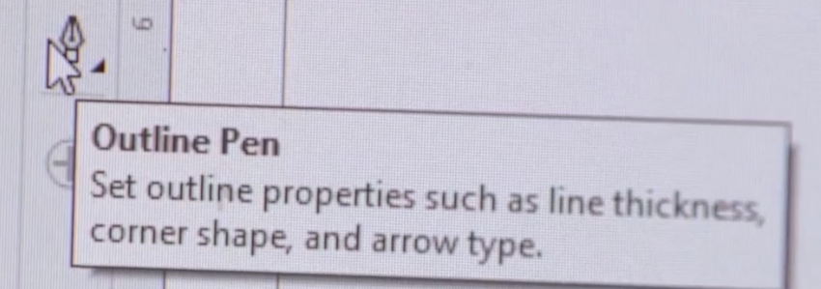
- By default, the Universal laser will “engrave/etch” any image, text, or design that is sent to it whether it is a vector or raster design. However, steps must be taken to have the laser “cut” or “mark” lines.

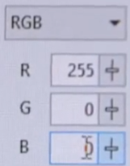
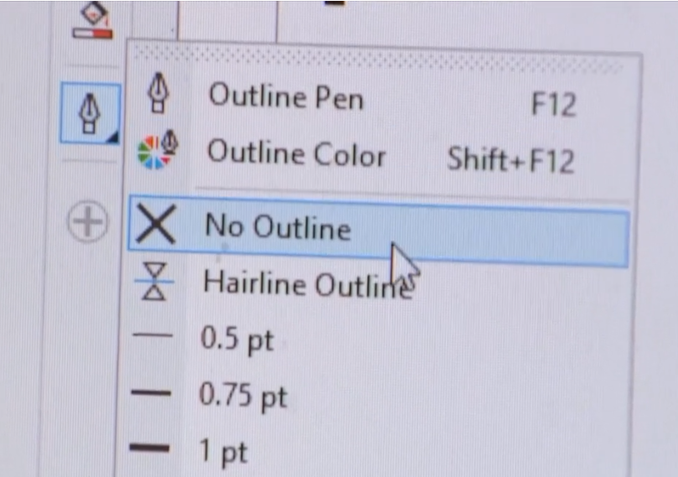
- One important tool to make note of in CorelDraw is the Outline Pen tool. It can be used to adjust vector lines. When you click on the Outline Pen, you will get a dropdown box that will let you select an outline color as well as the thickness of the outline—from hairline on up.
Note: You will need a pure red color to make a “cut” line, use settings—Red 255; Green 0; Blue 0.
- Creating Cut Lines—If you wanted any of the vector lines in your drawing to be cut all the way through (perhaps a border or the outline of your object), the line or border must have three properties:
- It must be a vector image
- The color of the line must be perfectly red
- The thickness (stroke) of the line must be “hairline”
When you click on an image nine small squares or anchor points will appear. More information on this on Pages 23-24. To make the edges hairline click on the “Object” in the tool bar. Scroll down to properties and click on properties. Object properties will appear on the right side of the computer screen. Choose “Outline” and from the dropdown, choose “Hairline.” To make the line red, right click on red in the color bar. All other parts of your design other than those lines red and hairline will be engraved/etched. NOTE: If you wanted any lines to be “Marked/Scored” (not a cut but deeper than engraving), you will need to make those lines “Blue and Hairline.”
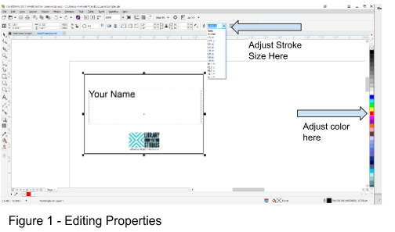

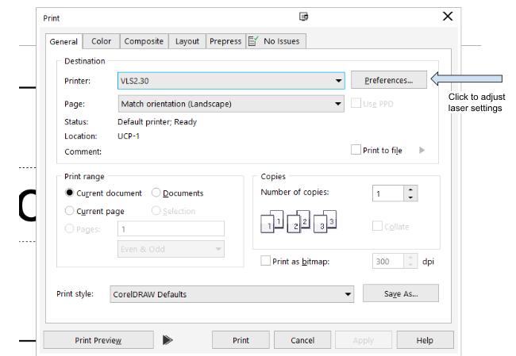
- Once the image is what you want it to be, send the file to the laser by selecting “File” then “Print.” Set the Printer to match your Universal Laser Cutter—perhaps it is the VLS2.30. Then Click “Preferences” (or “Properties” depending on the version of CorelDraw you have.)

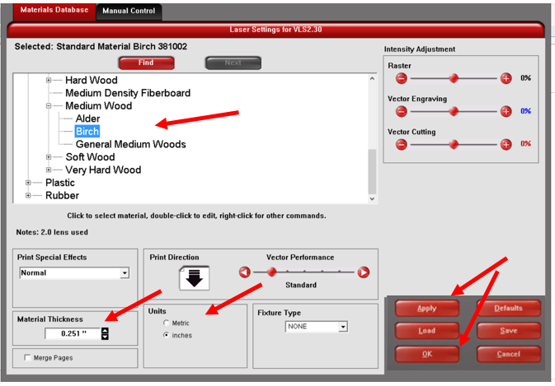
- Clicking Preferences opens the laser driver. In the Materials Database in the Universal interface, select the material you will be engraving. If you are using birch plywood, select: Natural  Wood  Medium Wood  Birch. In order for the laser cutter to focus the laser beam onto the work surface properly, it will need to position itself at a precise distance from the top of the work piece. Therefore, enter the precise height of the material to be lasered. If you have not yet measured the material thickness with the calipers, refer to Pages 14 and 39. Next, enter the material thickness in the “Material Thickness” box. Make sure the correct units of measure are reflected correctly in the “Units” box. Then finish by clicking on “Apply” then “OK.” (NOTE: Besides clicking on Preferences, the other way to get to this Materials Database is later in the UPC software—you can click on settings near the bottom right hand corner. Generally, it is better to make most adjustments in the above screen because some settings cannot be changed later in the UCP software such as print density and vector quality.)

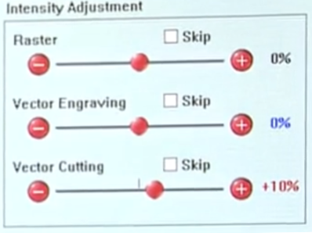
Note: If you are going to laser on the top of a 2” tall box, be aware that the material thickness you enter is 2 inches and not the thickness of the wood that makes up the sides of the box.

- Once the material type and thickness are entered, the laser cutter is programmed to automatically select optimal settings for power, speed, and the number of pulses per inch (PPI). However, advance users may adjust the intensities in the upper right hand corner of the materials database screen. If you increase the intensity more than 10 or 15 percent, you risk charring the material. If you adjust the Raster Slider, you can darken or lighten your engravings. Always remember to click on Apply after making adjustments, then OK. Advanced users can also go to the “Manual Control” tab to make additional adjustments to settings if they desire a specific look. For more information, see Page 57.

- Click on “Print” again.
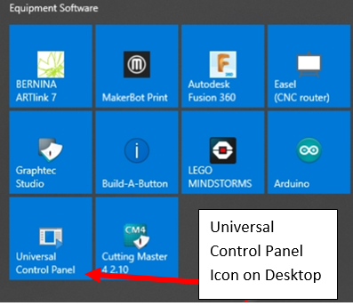
- Open the “Universal Control Panel” UCP software. You can get to that through a shortcut on the desktop that says “Universal Control Panel” or you might find it by looking for the Red Diamond Icon pictured here. Click on the Windows icon in the lower left corner and choose the “Universal Control Panel” UCP software.

- The Universal Laser System Control Panel allows you to configure your job. At the top and left, you will see a “ruler” to help you to see the current size of your graphic/design. There is a Preview Panel (a picture of your design), which shows a layout of your job and gives a preview as the laser is engraving and cutting.
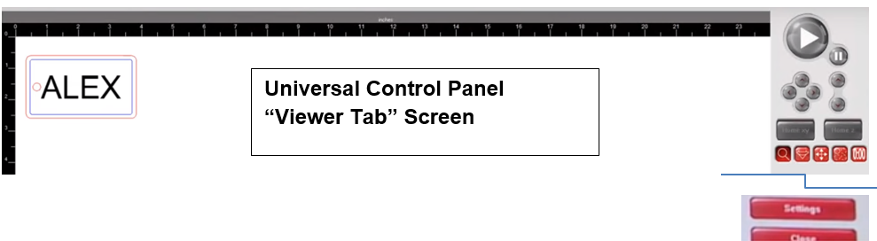
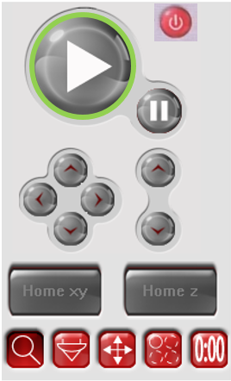
There are controls/buttons to the right. Each are described on Pages 21-22. The row of buttons under the “Home xy” and “Home z” buttons allows you to:
a. Zoom - Magnify your job to inspect potential problem areas (scrolling the wheel on your mouse will also allow you to zoom in and out)
b. Focus View - Click to move the laser head over your work piece—allowing use of the Red Diode pointer
c. Relocate View – Moves graphic around the material
d. Duplicate View - Create duplicates of your design
e. Estimate View - Estimates how long the job will take
Detailed information about how to use these tools can be found on Pages 22-24.

(Note: Back in Step 11, you found the materials database by clicking on preferences in the print screen. When you are in this Universal Control Panel, you can also get to the materials database (if needed) by clicking on “Settings” in the lower right hand corner.)

- If the laser system/the machine is not powered on—push the Power button on the machine. Powering on the laser triggers the machine to immediately home itself.

- Determine what fixture to use for the material you selected. If you are cutting through your material, you should use the Cutting Table (with honeycomb insert). If you are only engraving a flat material, you should use the Engraving Table (solid metal). If you are engraving around the curved perimeter of a cylindrical object such as a jar, use the Rotary Fixture. For more information, refer to Pages 12-13.

- If you need to change out a fixture, properly remove the currently installed fixture following the SOP’s instructions. Refer to the appropriate removal instructions (Engraving Table and Cutting Tables—Page 40; Rotary Fixture—Page 43).

- Install the fixture that matches your job following the SOP’s instructions (Engraving Table and Cutting Table—Page 42; Rotary Fixture—Page 43). For our Luggage Example Project, install the Cutting Table with the mesh insert.
IMPORTANT NOTE—Steps 20-24: In most cases you will not need to use the Focus Tool even when you change out a table/fixture—so you can skip Steps 20-24. However, poor performance of the machine may call for a resetting the Z Axis reading back to Zero. Some makerspaces may only want staff to work with the Focus Tool to check and reset the Z Axis reading. If you feel a recalibration is in order, please check with staff to see if makers are allowed to do Steps 20–24.

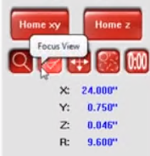
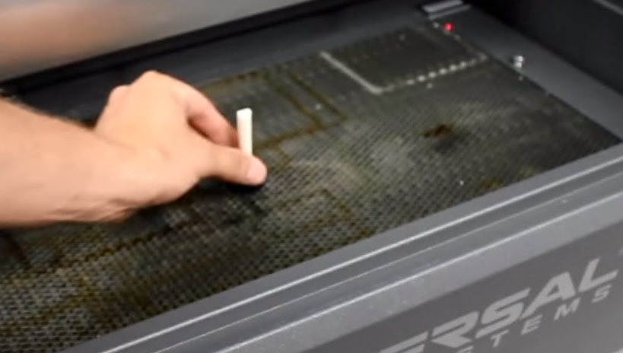

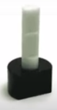
- Once the Cutting Table is installed, place the Focus Tool accessory on the mesh floor near the center.

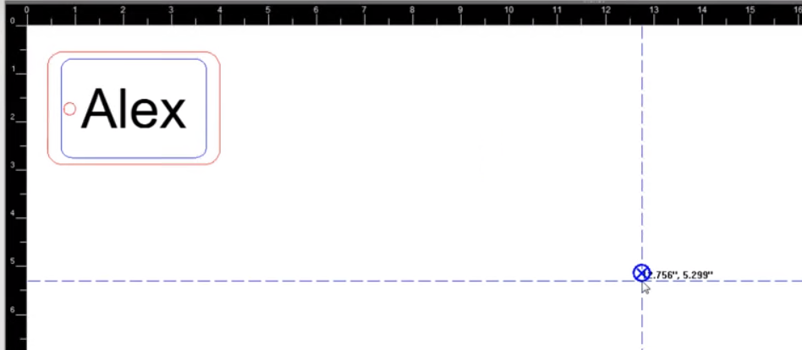
- Before you Click on the Focus View button in the software , first make sure you are zoomed out in the preview window by right-clicking on the mouse. Now click on the Focus View symbol. In the focus view, the curser changes to a blue target symbol with trailing dashed X-Y coordinates. Clicking the mouse in the preview window moves the focus carriage to the selected position or you can click and drag that blue target symbol somewhere in the middle. Doing so will bring the lens carriage to the middle of the table where you want to work with your Focus Tool you placed there.
Focus Tool is described more on Page 23
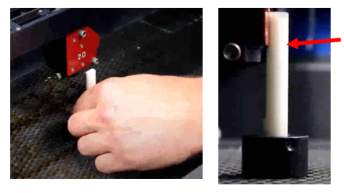
- Line up the focus tool on the mesh floor and just in front of the lens carriage with the red faceplate. With the lid still open, slowly move the table up with the “Up” Arrow on the top of the machine until the focus tool’s notch approaches the lens carriage. As it gets closer, make sure you hit the up arrow in taps rather than holding that button down or you will damage the lens carriage. If the notch pushes into the carriage, the tool will tilt forward. Back the floor back down with one push of the “Down” Arrow. See the picture on the perfect fit of the Focus Tool to the lens carriage (red arrow).

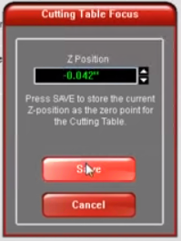
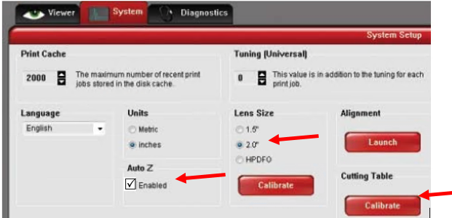
- Then back in the driver Click on the System Tab pictured below. There are three things on that tab for you to check. Confirm that the lens size checked matches the number printed on the lens carriage red cover—it is probably 2.0. The next thing to check is that the Auto Z Enabled Box is checked. Having Auto Z enabled tells the machine to also consider the thickness of the material we entered into the software earlier. Now click on the “Calibrate” button in the “Cutting Table Box.” Note that there are other buttons that are labeled “Calibrate” so make sure you are clicking on the one in the Cutting Table Box.
- The cutting table pop-up will show you how far the current table position calibration value is from the previously calibrated position. Here it shows a difference of .042”. Now we will Click SAVE to save the new calibrated position. As a safeguard, the machine will ask if you are sure you want to overwrite the previous calibrated position with the new value. Click on YES. Now if you click on the “Calibrate” under the cutting table, the new Z position reading should be .000. Return the Focus Tool to where it is kept—do not lose that tool.

IMPORTANT NOTE: Some videos might show the Focus Tool placed on top of the material on the table. This only works if the Auto Z enabled button is NOT checked. As a good rule of thumb, it is best to always set the Focus Tool directly on the table when calibrating AND click on “enable” Auto Z.
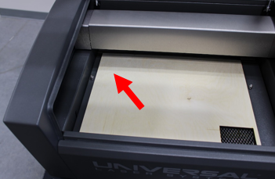
- Place the material you will be cutting/etching in the upper left hand corner of the cutting table. It is possible that your material may have flaws such as knotholes or it may already have pieces missing from past cutouts. There are two ways to make sure that your image will etch on a good spot on your material.

One way is to simply watch your machine do a “ghost cut.” With the lid of the laser OPEN/UP, press the Green “START” button. In a ghost cut, the laser will go through its motions as if it were lasering but because the lid is open, the laser beam will not fire. Instead, a Red Diode Pointer will be visible to aid in positioning material. The red pointer will follow the same path that the laser would follow if the lid were closed. Doing a ghost cut lets you verify that you have correctly placed the graphic in relation to the material on the laser bed. You may need to move the design to avoid defects such as knotholes. To stop the ghost cut press the Pause button in the UCP. Warning: DO NOT look directly into the red beam or use a reflective surface to redirect or view the beam.
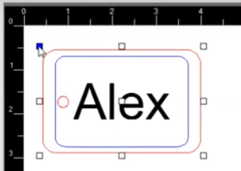

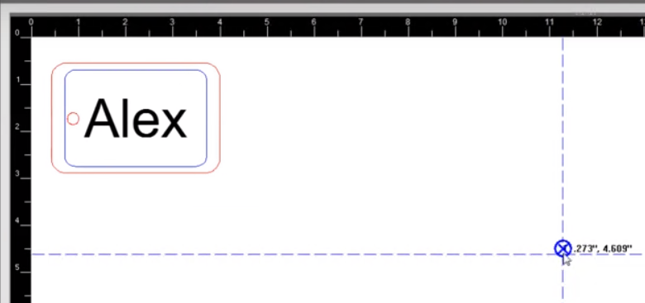
The other way to position your image onto the material is using Focus View as described in Step 21. This makes efficient use of the material, especially if there are several cutouts. Make sure the lid is open. Then right click in the preview window to make sure you are zoomed out—then click on the Focus View button. Drag the intersection of the dashed lines to where you want to place your image on the material and Click. In the Focus View, the curser changes to a blue target  symbol. The lens carriage on the machine moves to that position and you should see a red Diode dot on your material. You can continue to do this until the red dot is shining right where you want to move your design.

Back at the computer, Click on the Relocate Tool.
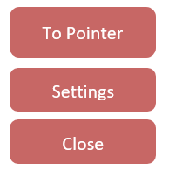
Doing so places anchor points around your graphic. Select the anchor that you want to coincide with the red dot on your material. If that dot is the top left corner of your graphic, click that one. The selected point will appear blue on the screen. Now Click on “To Pointer” button to relocate the image to the current laser carriage position—the red dot area.

Now you can either do a ghost cut as a final check or you can Click Focus View again and Click on all four corners of your graphic one as at time to lay down  targets. The red Diode dots will help you verify the location of your graphic on your material. Click on “To Pointer” to relocate the image to the current laser carriage position.
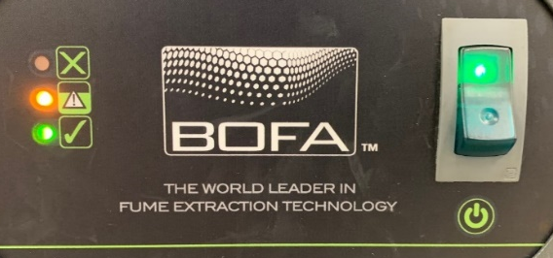
- Now that your material is measured, and your graphic is properly placed, you are ready to initiate laser processing of your job.
  - Close the lid of the laser machine.
  - Turn on the BOFA Air Filtration System (never operate the laser without an operating filtration system or if the BOFA is displaying a red “full” indicator light as this will harm the optics and create unwanted fumes—See Page 15 for filtration system details).
  - Push the Start button on the top of the laser cutter or the big green button in the UCP software.

- Remain with the machine while your project is processing/lasering and make sure the water spray bottle is available if needed. Do not stare at the laser as it could hurt your eyes. If you need to leave the machine mid-lasering, push the Pause button to pause the project. Upon your return, push the Pause button again so that your project picks up where it left off. Pushing the Start button after a Pause will start over from the beginning—you do not want to do that.
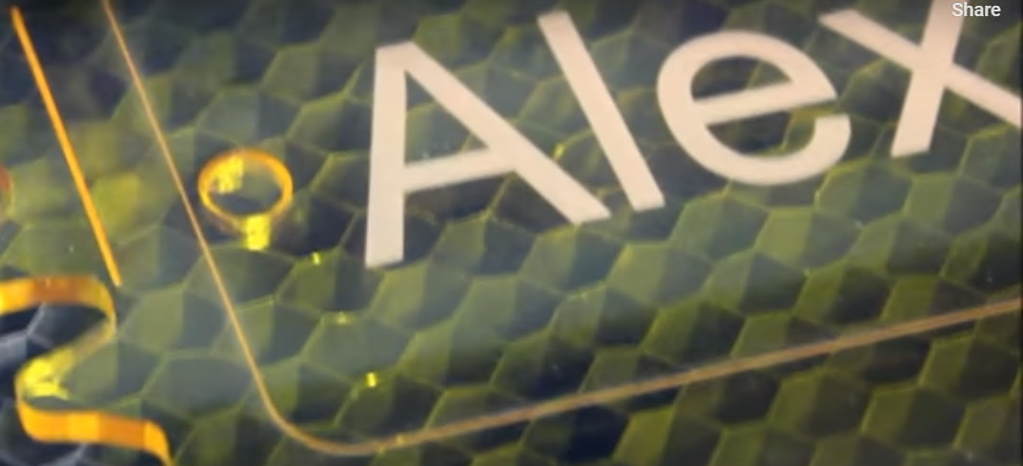
- After the machine is done lasering, the laser head will return to its home position. Leave the lid closed and the BOFA filtration system on for an additional 15 seconds to clear out any remaining fumes. Then open the lid/door, turn off the BOFA machine, and remove the newly cut piece and any leftover scraps.

- Follow the Closeout/Cleanup Procedures—see below.

Closeout/Cleanup Procedures

- Generally, if you changed the floor of the laser (Cutting Table, Engraving Table, or the Rotary Fixture), you will want to reinstall the floor you removed. Alternatively, you may ask makerspace staff to see if they want you to leave in the floor you installed. The most used floor is the Cutting Table (with honeycomb mesh insert), so generally if you removed that table it should probably be reinstalled. Refer to table/rotary removal and installation instructions on Pages 40-43.

- Turn the laser off by holding the power button a few seconds until the green and red LEDs turn off. Turn off the BOFA air filtration system by pressing down on the power switch if it is still on.

- Clean up loose pieces of unwanted material around the area.

- Make sure that tables/fixtures you removed along with accessories such as the digital calipers, focus tool, and water spray bottle are returned to their designated resting spots.

Luggage Tag Example using CorelDraw
Start with Steps 1-4 on Page 26 then pick up here.
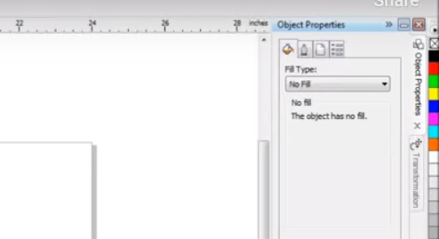
Assuming someone downloaded the Universal Laser Systems Color Pallet into CorelDraw, you will find colors that you can use in the right hand bar.
4a) Now that the size of your material has been entered into CorelDraw, we want to think about the luggage tag we will be designing. In our example, we will do the following design so that we can use several CorelDraw tools.

- The perimeter will be a rectangle that will be “cut” line and we will make the corners rounded.
- We will have an inner rectangle (just inside that outer border) that we will “Mark” or “Score.” This rectangle will also have rounded corners.
- We will cut a ¼” round hole, centered on one end to put a cord through later.
- We will “Etch” a name onto our luggage tag—centered.

Note: “Cut,” “Mark” and “Etch” are all described in more detail on Page 17.

4b. Since we will have parts of our graphic that will be cut, marked/scored, and etched we will need to use the colors and line thicknesses needed to accomplish those three scenarios as follows: (Note: Cut and Mark lines must also be Vector lines, but we know these are vectors because we will be creating them in CorelDraw.)

- Cut lines must be hairline and RED (Red 255; Blue & Green 0).
- Lines to be “Marked/Scores must be hairline and BLUE (Blue 255).
- The “Etched” name will be BLACK. (Generally etched elements will be grayscale but if you want a darker solid background such as the inside of text, make those elements solid black.

4c. You can choose to select your line width up front before we create our rectangles or afterwards. To set your line width up front, Click on the Outline Pen tool and then click on Hairline Outline. You can even make that your default width.
4d. Now we will click on the Rectangle tool as shown below. Then Click and Drag to add a rectangle to your canvas. We will repeat that and add a second rectangle to work with.

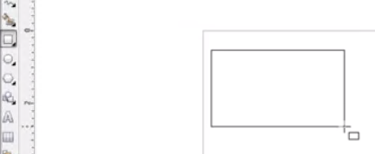
Rectangle Tool

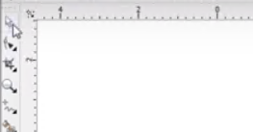
4e. Now we will click on the Pick Tool (the Arrow) to capture both of our rectangles by pulling a box around them.
Pick tool

4f. Once the two boxes are captured with the pick tool, Click on Arrange, then Align and Distribute, then Align Centers Vertically to put one box into the other box.
Arrange

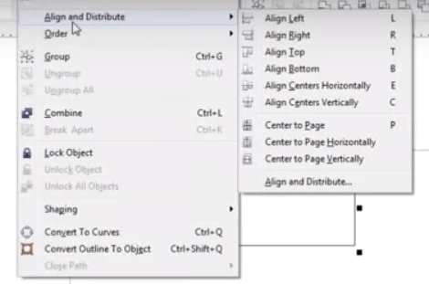
You will note that the graphic offers shortcut letters for the alignment options as follows that you can use instead of going to these dropdowns:

L Align Left
R Align Right
T Align Top
B Align Bottom
E Align Centers Horizontally
C Align Centers Vertically
P Center to Page
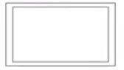
Result of Align Centers Vertically

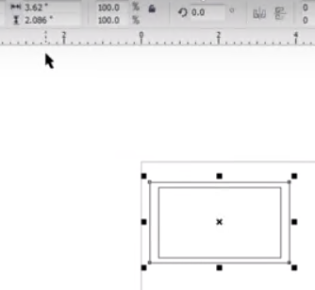
4g. We could have “sized” our rectangles before aligning them or after they are aligned which we will do now. We will first select our outer rectangle.

Then we will go to the top ribbon and type in the width and height of our outer box. Enter 4 inches wide and 2.5 inches tall.

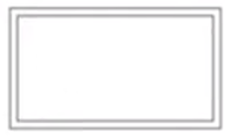
Then we will click on our inner box, and again go to the top ribbon and type in the width and height of that box. If for instance we want our inside rectangle ¼” inside the outer border rectangle those two measurements will be ½” less than the two measurements we entered for the inner box. So enter 3.5 inches wide and 2 inches” tall.

Now our two rectangles look much more proportional.

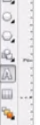
4h. Now we will add out third design component, a name. To add that we will click on the Text Tool which features the “letter A.” Then we will click inside the box to begin our typing there. After typing the name, click the name and drag it to make it the size you want.
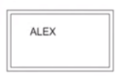
Text Tool

To center the name in the rectangles we can capture every element with our Pick Tool again like we did in Steps 4e and 4f, then we can go back to our Arrange, Align and Distribute, Align Centers Vertically, or we can type the shortcut, “C.” Doing so will center the name on the luggage tag.


4i. Now we will add that hole to cut for our cord to be inserted later. We will find and Click the Circle Tool in the left tool bar (much like we did the rectangle tool earlier.) We will place that circle to the left of the name and inside the inner rectangle by Clicking, then Dragging. Since we will fix both the horizontal placement and the size of the circle in the next step, we just need to get the circle close to where we want it.

4j. If we want a hole that is ¼ inch in diameter, go to the width and height area and type in .25” for both width and height. Since we want to make sure our circle is centered from top to bottom in relation to the outside luggage tag border, we will Click the circle first (since that’s the object to be moved), and then we will HOLD-SHIFT and Click the outside rectangle. Then as in Step 4e, we will Click on “Arrange” then Align Distribute, and this time Align Centers Horizontally, or we can type the shortcut, “E.”

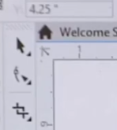
4k. Now that the size of our rectangles are set, we will now round the corners of both. (NOTE: The best time to round corners is after you have sized your rectangles. If you change the size of your object after you round the corners, the curves can become distorted unless you resize the shape using special steps.) To round the corners, first Click on the Shape Tool or shortcut F10. Then Click on the outer rectangle, grab the corner anchor box and drag it inwards until you achieve the amount of rounding you desire. You will notice that all four corners are shaped at the same time.
SHAPE TOOL
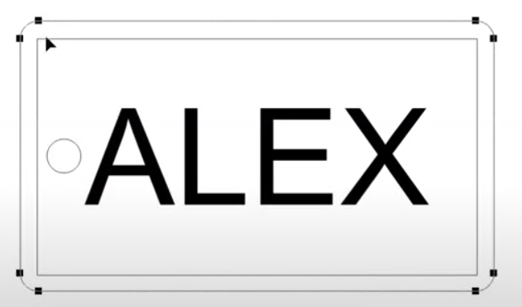
We will repeat this step on the inner rectangle to round its corners as well. You may want to zoom in on the image to compare the corners of both rectangles to see if they match. Left clicking the mouse zooms in and right clicking zooms out.

4l. We want to change the outer rectangle and the circle hole to “Cut” lines and the inner rectangle to a “Mark/Score” line. A Mark line is similar to a cut line but not at deep.
As we mentioned earlier:
- Cut lines must be hairline and RED (Red 255; Blue & Green 0).
- Lines to be “Marked/Scores must be hairline and BLUE (Blue 255).
- The text that we would like engraved/etch in a solid fashion should remain BLACK.
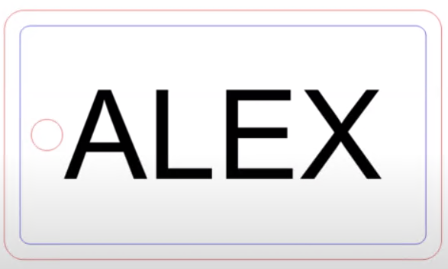
First Click to select the outer rectangle and then HOLD SHIFT to also Click/select the circle. Then Right Click on Red in the left color bar. Confirm that the line width is set to hairline if it is not already. You will find Hairline in the Pen Tool dropdown box.

Then Click to select the inner rectangle and then Right Click on Blue in the left color bar. Again, check if the line width is hairline. Anything left black will be engraved/etched.

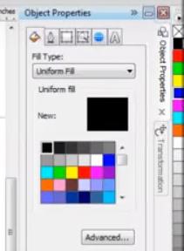
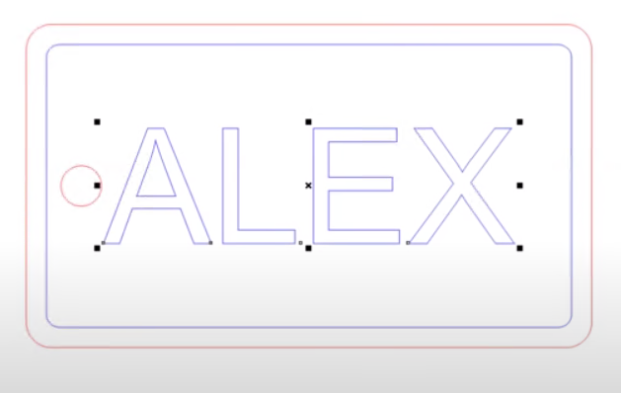
4m. You will notice that our text is solid black and there might be times that you want the text just to be outlined rather than solid. So let us review “Fill” vs. “Stroke.” The Stroke is the outline and the Fill is what fills the outline. The text in the graphic above has both the outline and the fill set to black. However, if we want an outline only of our text, we need to set the Fill to “No Color” leaving the outline/stroke as black. To do this we will first Click on/select our text, and then we will go to that color bar to the right. Right Click on a color to set the color of the Outline/Stroke. Left Click on a color to set the color/or absence of color for the Fill. In this case, we want to Left Click on the “X” in the top box of the color column to indicate “no color” for the fill. See the result of doing so in the graphic above. However, we want to also etch the inside of the letters so we will return our text to have the Stroke and the Fill as Black (See the graphic in 4l on the previous page).

4n. The luggage tag graphic is now ready so we can pick up with Step 10 on Page 27.

Material Setup (Measuring and Loading your Material)

Measuring Material

1. Using the digital calipers measure the thickness of your material and write this value down—take note as to whether you measured in metrics or inches as you will need to enter those measurements using those same units of measurement. When laser engraving a box or a glass dish, the thickness is not how thick the walls of your dish or box are but rather how thick or high the dish will be sitting above the bed floor. See the illustration below as to how to measure a box or baking dish. (NOTE: If you engrave on the bottom of the engraving dish—bottom up, you will need to reverse the image if you want to view the image when you look down into the dish.) In either case, what you need to enter is the distance between the bed floor and the top of what you will be lasering which generally is referred to as “thickness.” Refer to “Operating the Digital Calipers on Page 14.

Measuring Thickness of a Board Measuring Thickness (of a glass
Casserole dish--height of the pan)

Loading Material

Before laser processing material, you will need to load material into the laser system and then focus the laser system onto the top surface of the material.
Open the top door/lid to the laser system and place material to be laser processed onto the Engraving (solid) Table, or the Cutting (honeycomb mesh) Table up against the upper left hand corner of the table. (Refer to Page 12 as to which Table to use for your situation). You may need to manually move the table down (using the down arrow), to allow clearance to fit thicker materials into the machine. Leave the lid open.

Special Note: Most times you will place the material up against the upper left hand corner of the table. More information on “Positioning the Material” can be found on Page 48.
Removing the Cutting Table (with Honeycomb Mesh Insert)
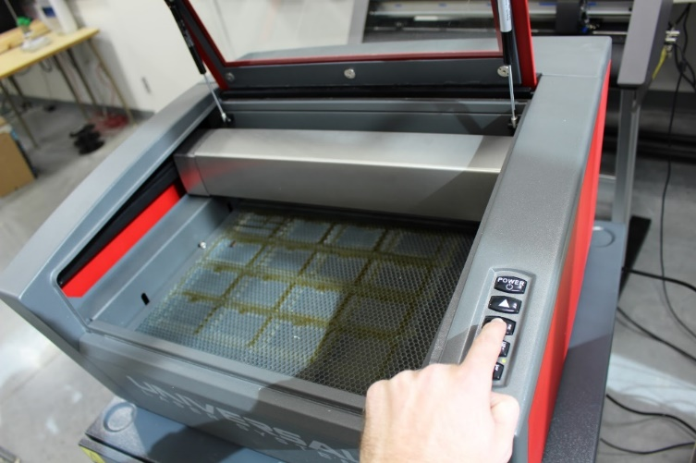
- To remove the existing table, first power on the laser (by pushing the Power button) and fully lowering the table by pressing and holding the “Down Arrow” button on the right-hand side of the laser. If you do not lower the table to the very bottom, you risk damage the laser parts.
Lowering the Laser Bed
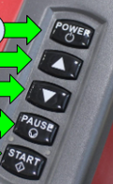

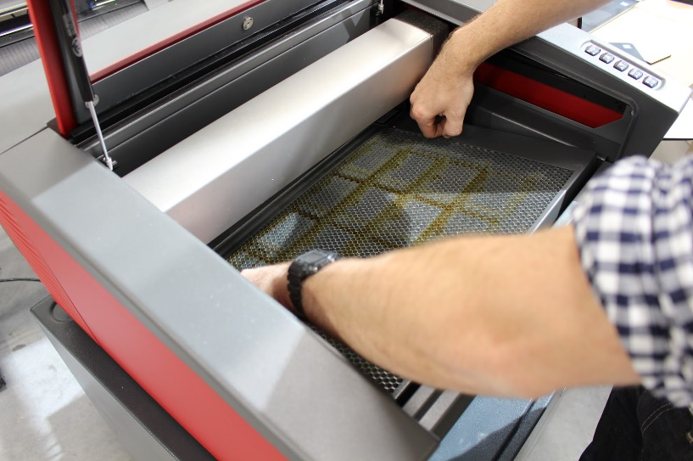
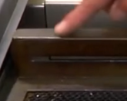
- Loosen the two thumbscrews. Lift the cutting/vector table up and out using the two thumbscrews on the left and right of the table’s frame. Be careful when lifting out the meshed floor so that the raised edge on the back edge does not bump into the gantry and damage the lens assembly carriage inside. You may need to tilt the table (the side closest to you up) to remove it safely.
Lift out the cutting table using the thumbscrews as handles—CAREFUL, the back edge of the meshed table has a raised edge that could catch on the gantry above.

Removing the Engraving Table (Solid Metal One)

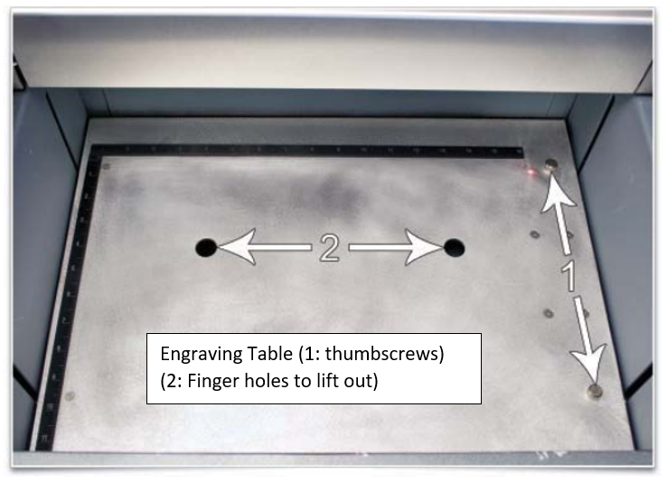
- Turn on the laser by pushing the Power button. Fully lower the table by pressing and holding the “Down Arrow” button on the machine. (If you do not lower the table to the very bottom, you risk damage to machine parts.

- Remove the engraving table by loosening the two captive thumbscrews, then using the finger holes, carefully lift (then tilting) the table up and out of the machine. Make sure you do not strike the gantry or the lens carriage above.
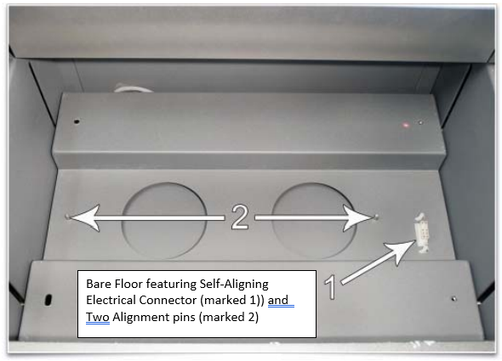
Laser Cavity When No Table or Fixtures are Installed

Here is a view of the laser cavity without a fixture installed. Note the self-aligning electrical connector to the right and the two alignment pins (outside the two big circles.)
Thumb- Screw Holes

It is good to note that the features of the bare floor pairs up nicely to the bottom of the cutting table, the engraving table, and the rotary fixture.
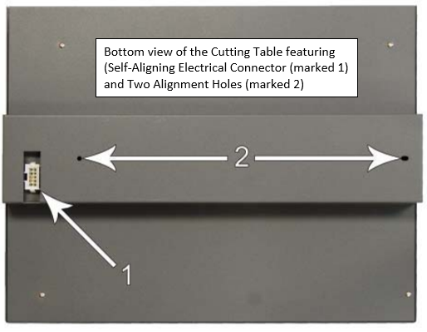

The Bottom of the Cutting Table

In this view of the bottom of the Cutting Table, take note of the Self-Aligning Electrical Connector and the two Alignment Holes. When you seat this table into the machine, make sure the Aligning Electrical Connector is on the right side.

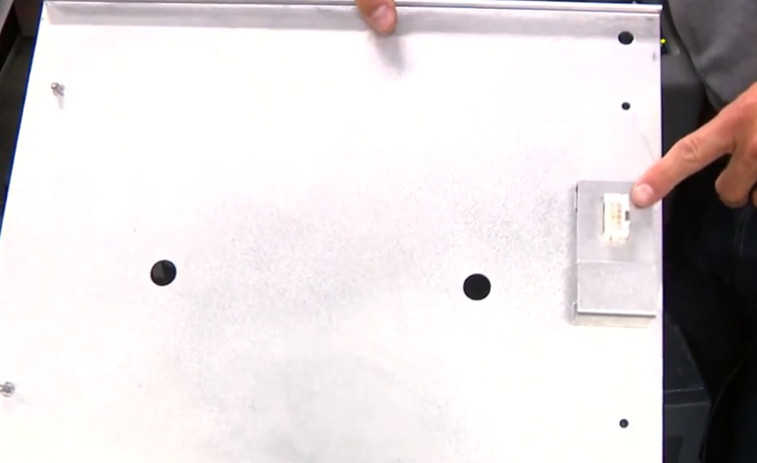
The Bottom of the Engraving Table
Bottom of Engraving Table
In this view of the bottom of the Engraving Table, there are:

Two finger holes

Self-Aligning Electrical Connector

The backside of two Thumbscrews

Installing the Engraving/Raster Table--Solid Metal (with machine on)

To engrave a heavy object, or an object taller than 3 inches, the cutting/vector table (with mesh insert), will need to be replaced with the engraving table (solid metal). Removal instructions are provided on Page 40.
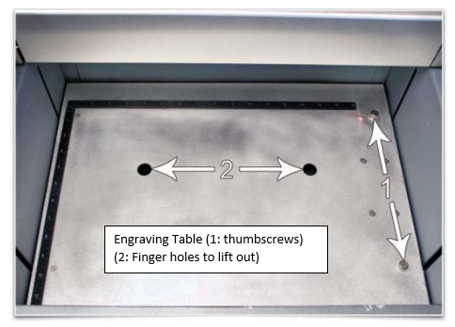
- Before installing the Engraving Table (shown installed here), view the pictures showing the features of the machine’s empty cavity and the bottom of the engraving table as shown on the previous page. Install the Engaving Table by inserting your fingers into the holes and placing the table into the bed of the laser. Take care not to hit the gantry or the lens carriage with the table. You may need to tilt the table down to clear those items before putting it into place. Once in, you may need to adjust the placement until it engages the connector and the alignment pins. Hand-tighten the two thumbscrews. The table will be detected automatically and the Z-axis zero position will be adjusted automatically to the top surface of the table.

- Once in place, hand tighten the thumbscrews, marked “1” in the picture above.

Installing the Cutting/Vector Table--Mesh Insert) (with machine on)

If you are going be cutting your material, you will want to make sure that the fixture installed is the Cutting Table with the mesh insert.

Before installing the Cutting Table, view the pictures showing the features of the machine’s empty cavity and the bottom of the Cutting Table as shown on the previous page.

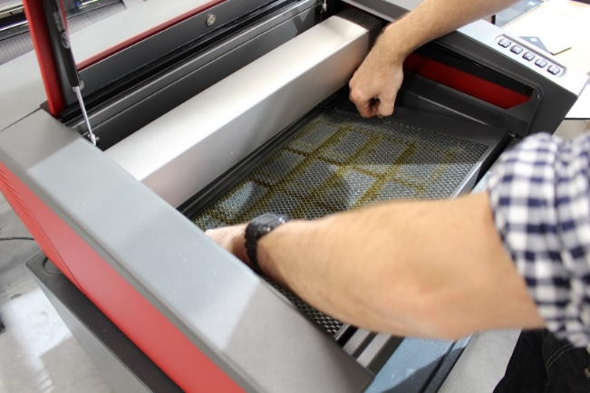
- Make sure the bed is completely down by pressing and holding the down arrow on the machine. After you properly remove the other table or the rotary table, use the thumbscrews on the side of the Cutting Table as handles. Tilt the back end of the table down as it enters the machine so it does not collide with the gantry above.

- Adjust it until it engages the connector and alignment pins. Hand-tighten the two thumbscrews. The cutting table will be detected automatically and z-axis zero position will be adjusted automatically to the top surface of the cutting table.
Installing the Rotary Fixture (with machine on)

If you wanted to etch the sides of a cylindrical object such as a glass jar you will need to remove the engraving or cutting table and install the Rotary Fixture.

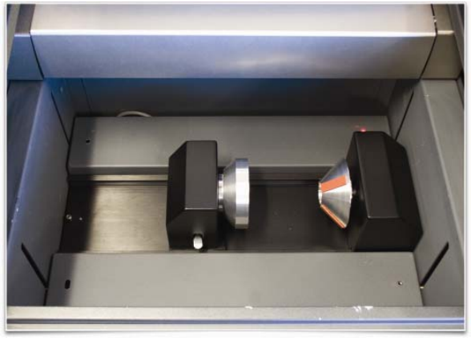
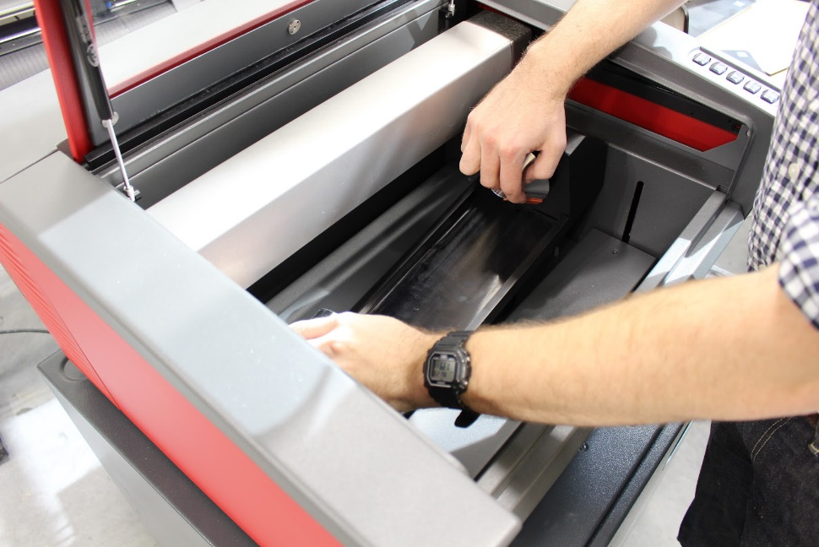
- With the table removed, you will see a large recessed slot with a self-aligning rotary electrical connector to the right side. You will not need to calibrate the rotary position because that was done when the machine was installed. Make sure to use the Down Arrow so the bed is lowered before inserting the Rotary Fixture. With the machine powered on, insert the Rotary Fixture by holding the heavy end of the fixture that features an internal motor and a cone shaped end (the headstock), with your right hand. Slowly lower the rotary fixture into the recessed area of the laser cavity and adjust until the Self-Aligning Electrical Connector on the bottom engages, the alignment pins protrude through the alignment holes in the base of the fixture, and the rotary is sitting flat. The rotary will indicate that it is installed properly by automatically rotating its cone headstock slightly.
Installing the Rotary Fixture
View of Installed Rotary Fixture

Removing the Rotary Fixture

To remove the rotary fixture from the laser, first make sure that you have removed the item that you may have engraved. Then simply lift the fixture up and out, making sure to support the heavy right side while being careful not to collide with any other laser parts.

Designing for Rotary Fixture

When designing a graphic for the rotary fixture most of the same concepts for engraving apply when designing for a flat surface. The differences are as follows:
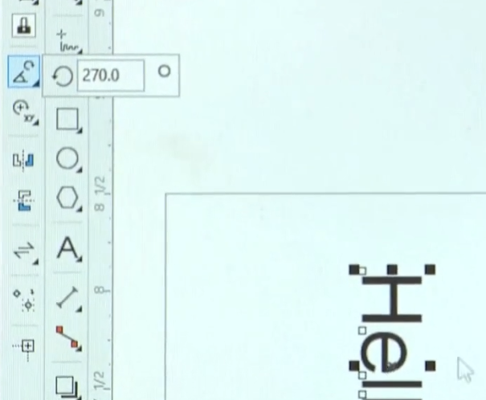
- Most rotary engravings are done on glass, which cannot be vector cut on desktop lasers. However, you can engrave using raster or vector designs and you can vector mark assuming your item does not have too thin of walls.
- Because cylindrical materials are inserted on its side with the top to the right, make sure to rotate the design 90 degrees to the right so it will align with the rotary fixture. To accomplish that in CorelDraw, select Text/Art, then Click on the Rotate/Angle tool. Enter 270 degrees so that the top of your graphic is now facing to the right.

Be aware that there are considerations for selecting glassware. See Pages 49-50 for “Etching Glassware Guidance” tips.

Measuring Cylindrical Items for Rotary Fixture
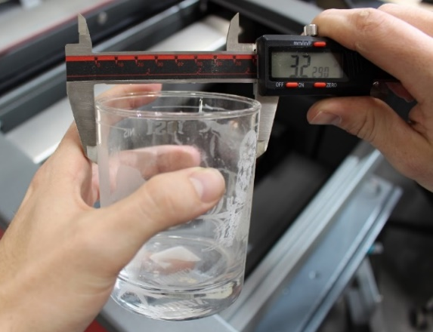
Measure the diameter of your object in the area where the engraving or marking is to be located by using electronic calipers--write it down. (Refer to Operating the Digital Calipers on Page 14.) Cylinder shaped items such as jars or glasses that you want to insert into the rotary fixture, should have straight up and down sides. Angled sides such as a martini glass or beer glass where the diameter increases from one end to the other, will not laser effectively unless you make adjustments to the fixture (Refer to Page 49).
Note: Size Limitation to this Rotary Fixture are:
Measuring Diameter with Digital Calipers
Minimum Diameter: 1.0 inch
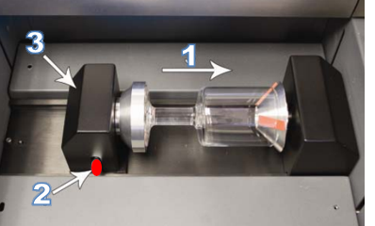
Maximum Diameter: 5.5 inches
Maximum Height: 9.5 Inches

Loading the Rotary Fixture

Does the object have a best side to etch because it has a handle or a visible seam? Make sure to place the part you want etched facing straight up to coincide with the center of the design.
(1) Place the open mouth of your object in the cone shaped head stock—the fixed end on the right side of the rotary fixture; (2) Lift up on the red lever on the Rotary Engraving Fixture; (3) and slide the tailstock towards the right side until you are up firmly against your object to be lasered. When the object is both centered and snug, lower the red lever to lock the object in place.
Rotary Engraving--Software Settings & Processing Cylindrical Piece

- Open CorelDraw, open a new file and create the basic artwork you plan to print. (More design notes on Page 44.) Click on Print. Make sure the ULS laser system drive is selected and open printer properties dialog. Click on Preferences to adjust laser settings.

- This brings up the Materials Database Menu. If you are engraving glassware, select “Glass” then “Soda-Lime Glass” (unless you are engraving expensive lead crystal).
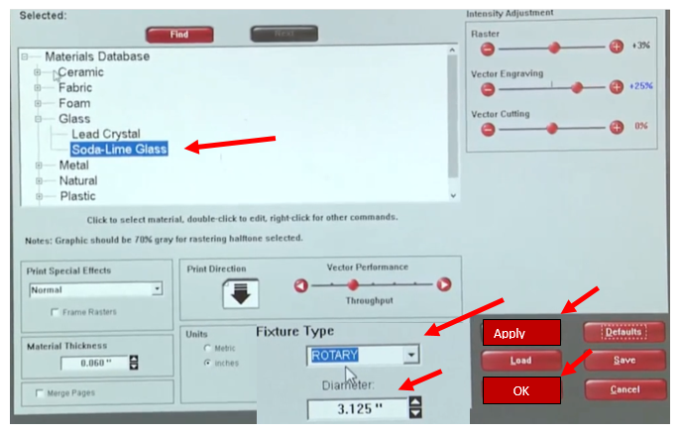
- Change “Fixture Type” to “Rotary” and enter the diameter of your object as measured with the digital calipers. Press “Apply” then “OK.”
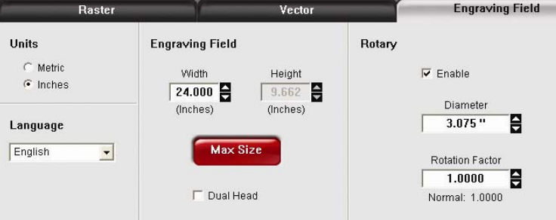
- Go to the Manual Driver Tab and click on the Engraving Field Sub Tab. Click on “Max Size” to maximize the field. Then check the “Enable” box in the Rotary section to enable Rotary mode. Type in the diameter of the material measured earlier. Notice that while typing in the diameter, the height dimension of the engraving field changes automatically. The new height value is equal to the circumference of the material. Make note of the new engraving field size.
- Once you have the new engraving field size, exit the printer driver properties dialog. In the graphics software, change the page size to equal the new engraving field size from the printer driver dialog box you wrote down.

- If you have not already done so, position your graphic on the page so it is located horizontally within the upper and lower engraving limits that you determined earlier and center the graphic vertically as shown below.
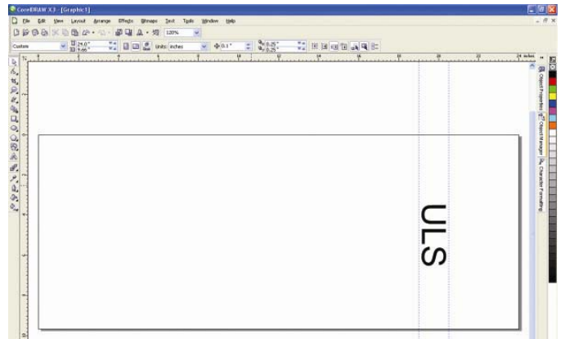

- Next, align your design with the material in the rotary fixture. You can use the X-axis ruler or use the Red Diode Pointer/Dot and the X-Y coordinate display in the UCP to position the graphics in the X Axis. (You can refer to “Relocate View” information on Pages 23-24 and Step 25 on Page 32.) Using the Navigation buttons in the UCP, position the Focus Carriage above the material. Move the carriage left or right until the center of the carriage or the Red Dot is located where you would like the top of the graphic to start. Make note of the X coordinate in the UCP. Now position the center of the carriage/the Red Dot where you would like your graphic to end on the material. Make note of the X coordinate in the UCP.

- To confirm that your graphic will be etched on the correct spot on your item, you may want to leave the laser lid open and do a “ghost” cut (See Pages 32, Step 25). Open the Print Dialog, press “Print.” Then with the lid open, press “Start.”

- When you are satisfied with the placement, close the lid, start the filtration system, and push the laser’s Start button. Remain with the machine during the engraving process. Once complete, leave the lid closed and the BOFA on another 15 seconds.

- You may open the lid, turn off the BOFA, and remove your engraved piece. If it is glass, wash the glass with water and paper towels to remove any sharp loose glass particles that might remain on the glass before you handle the engraved areas. Follow the Closeout/Cleanup Procedures as described on Page 33.
Troubleshooting

Problem: Laser will not power on.

Solution: Make sure the laser is connected to a functioning outlet or power strip AND make sure the USB cable is properly connected to a powered on computer, if the USB cable is not plugged in the laser will not power on.

Problem: I had a proper “cut” line with all three properties but although it tried to cut all the way through, it did not complete the cut.
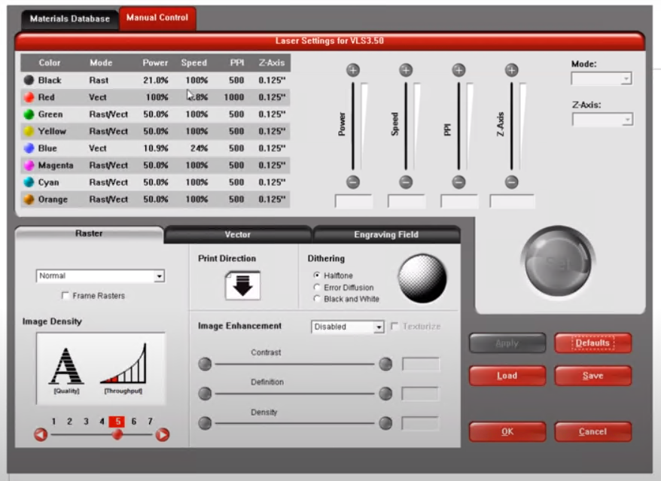
Solution: In the future, if you see that the cut did not go all the way through, do not move the material. You can try running the cut a second or third time to get the job done. Before you do, increase the Power by 10 percent and decrease the Speed by 10 percent. You can do that is the Manual Control Tab.

Note that chipboard and plywood have glue between layers so sometimes it is just too difficult to cut. The thicker the material, the harder it will be to cut through.

Problem: The laser produces blurry images, does not cut as expected, it produces large flames, or the cut line is thick and scorched.

Possible Solutions:
- Double check that your calipers are properly calibrated by fully closing them and checking that the display reads 0.000 (refer to Page 14). Confirm the measurement of your material in the Laser Settings. Additionally in the laser settings confirm that “Auto Z” is enabled (refer to Page 31).
- You may also want to check if the type of material that you are working with was correctly entered into the software (refer to Page 18).
- Your laser mirrors and lenses may need to be cleaned, contact the Library Innovation Studio staff for more information. (Makerspace staff should check instructions on Pages 51-53 on how to find and clean the “handled mirror,” the “mirror” and “focus lens,” and the front of the “Beam Window.” Dirty optics could through off the focus.
- If those above fail and the issue persists, makerspace staff may need to recalibrate the machine using the “Focus Tool.” They should refer to Pages 30-31 to remind them of the steps to focusing the machine with one of the tables in or the rotary cutter (if that is where the issue occurred).

Positioning the Material

As promised on Page 39, here is additional information about positioning the material inside the Laser machine.

Position the material so that it is aligned with the graphics to be engraved, cut or marked. There are a few methods that can be used to accomplish this.
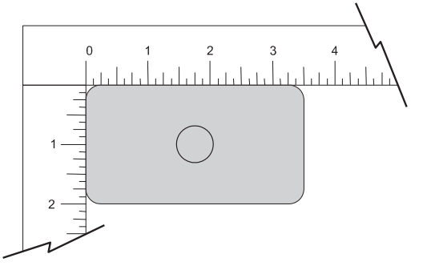
One method is to use the rulers on the laser system’s processing table and the corresponding rulers in the preview window of the UCP to align your material with the graphics in your laser job file. It is often useful to push the material up against the rulers and position your graphics accordingly before printing.

A second method is to use the relocation feature in the UCP to move your graphics to your material. (Discussed on Pages 23-24 and 32.)

A third method is to use fixturing to position your material. This is especially useful for odd shaped materials. An example of this might be to engrave on precut materials like a precut ornament. First, you can use the laser system to create the fixturing. For example, fixturing can be made out of acrylic by placing a piece of acrylic against the rulers in the laser system and cutting the shape of the material to be laser processed out of the acrylic. You can then place the material in the “cut out template” you made earlier to position the pre-cut shaped ornaments accurately.

Generally, fixturing is not needed because you can engrave your ornament then cut it out of cardboard, wood, or acrylic in the same file. However, it is possible you found precut materials that you wish to finish up with your laser cutter.

Lasering Glassware Guide

Laser engraving glassware is an easy way to permanently customize a glass, a baking dish, or another piece of glass. Be aware that there are limitations with lasering glass, namely that glass does not etch with different shades. Glass is either etched or it isn’t, so everything will appear to be the same color when etched onto glass. Manipulating designs by increasing contrast may yield good results.

Note that when glass is etched a very bright light is given off. It is not enough to harm the user, but it is best to cover the viewing window with a piece of paper to prevent people nearby from looking directly at the glass.

When etching a glass casserole or anything that will come in contact with food, it is best to etch on the reverse side so bits of food are less likely to get stuck in the etching. Designs etched in this way must be mirrored so they are in the correct orientation when the pan is flipped right-side up and the design if viewed from the other side.

If etching the bottom of a glass baking dish, make sure to measure the height of the pan and not just the wall thickness when setting it up in the Laser Preferences.

When glass is etched there are small burrs created at the edge of the etching. These will come off when washed for the first time. Washing with water and a paper towel will also get off glass fragments that could penetrate your skin.

The only safe way to etch a mirror is etching the mirror with the mirror laid face down on the engraving table. The painted backing is lasered off. “Reverse” the image because you will be lasering on the back but viewing the design from the mirror side. Never laser the reflective side of the mirror. This can damage your eyes and it will also damage the machine’s expensive mirror and lens. Some makerspaces do not allow makers to laser mirrors, as it is too easy to forget to place the mirror, mirror side down.

After you etch glass, wash the glass with water and paper towels to remove any sharp loose glass particles that might remain on the glass before you handle the engraved areas.

Engraving a Tapered Object (straight—but slanted at an angle)

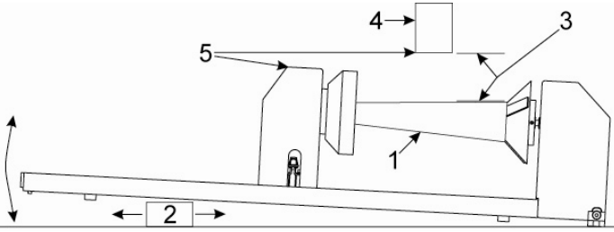
If engraving a tapered object (labeled 1 in the graphic), the Rotary Fixture can be tilted to maintain proper focus on the tapered surface. To do this, lift the left end of the fixture and place a spacer (labeled 2) underneath. Slide the spacer left and right until the tapered surface of the object is parallel (labeled 3) to the material support table. Make sure all parts of the rotary fixture clear the motion system. NOTE: Using a spacer will require a Rotary Fixture Re-calibration. Check with makerspace staff. Then you will MUST ALSO Re-calibrate the rotary after the spacer is remove. For this reason, the makerspace may not allow the use of this method to laser tapered objects.

Selecting Glassware to Laser

Bottles, Jars, Carafes, Glasses, Wine Glasses, Vases (using Laser’s Rotary Fixture)
Diameter: 1 inch Minimum to 5.5 inches Maximum
Height: 1 inch Minimum to 9.5 inches Maximum
Note: The “etching” location should be nearly straight up and down rather than angled. Angled sides could work if you used a spacer under the left side of the rotary fixture that brings the side of the glass parallel to the gantry. See Page 49.

The first row of glassware works best using the Rotary Fixture because the sides where you would etch are vertical.
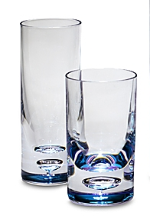 |  |   Use Rotary Fixture for this row |  |  |  |  |  | 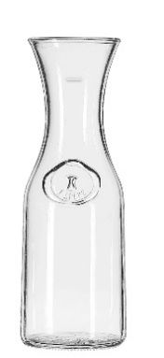
Issues with the glassware in the row below—some are too angled to etch properly without making adjustments. The square one will not etch using the rotary unit—but if the sides are vertical when laid on its side, you could etch it lying on the engraving table.
Those that would not etch properly in the Rotary Fixture without adjustments: |  |   Angled sides could work if you used a spacer under the left side of the rotary fixture that brings the side of the glass parallel to the gantry. See Page 49 for engraving tapered sides. |  |  |  |  |  |   Flat sides don’t work using rotary cutter
Glassware with flat sides can be etched if they are not taller than 4 inches when laid on their sides (but with these, you would use the Engraving Table rather than the Rotary Fixture.) The Engraving Table is thinner than the Cutting Table so it is able to etch the sides of flat bottles that are a bit wider (taller when laid on their sides). Short “flat bottomed” glasses can also be etched on their bottom side (place bottom up on the Engraving Table). Remember to reverse the image if you want to view the etched image while looking down into the glass.
 | 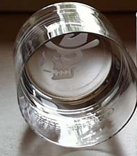 |  |   Use Solid Engraving Table for this row--Flat sides or bottom |  |  |  | 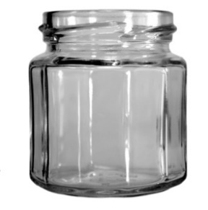
For Makerspace Staff ONLY

Maintenance of Optics

Several optics should be inspected periodically to see if they should be cleaned. Dirty optics could cause the laser to produce blurry images or poor cut quality. If your laser cutter is used often, you might need to do this inspection every other day. Optics that should be checked include:

“Handled mirror” Located under the gantry lid near the left side of the gantry

“Mirror” Located behind the red front cover plate of the Focus Carriage

“Focus lens” Also located behind the red front cover plate of the Focus Carriage

“Beam Window” Located at the back left corner behind the Gantry

CAUTIONS: Although a visual inspection of the mirrors, beam window and focus lens should be performed regularly, DO NOT clean an optic that appears clean.

- Excessive cleaning can damage the optical coatings.
- To prevent contamination, wash your hands thoroughly before handling and cleaning any optic—especially if you use lotion on your hands.
- Do NOT touch the optical surfaces with your fingers; handle optics only by the edge or optical housing. Fingerprints can damage the optical coatings.
- Never clean any optic right after engraving or cutting because the optic may be hot and the cool lens cleaning solution may thermally shock the optic and crack it.
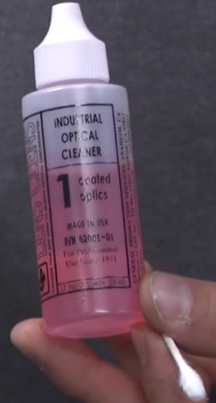

Cleaning Method (Mirrors/Focus Lens/Beam Window)

To clean any of the mirrors, focus lens or the outside of the beam window, follow the following cleaning method.

- Use the “Industrial Optical Cleaner” that is recommended by Universal. Do NOT use any other cleaners or solutions.
- Use a clean Cotton Swab (Q-Tip or other brand)
- Saturate the end of the swab with the Industrial Optical Cleaner
- Gently “roll” the cotton swab across the surface once. Do not drag the swab or roll it back and forth, as this can scratch the surface you are cleaning. If the surface did not come clean in the first pass, use a fresh cotton swab and repeat the procedure. DO NOT attempt to dry the lens or mirror with any cloths or towels.

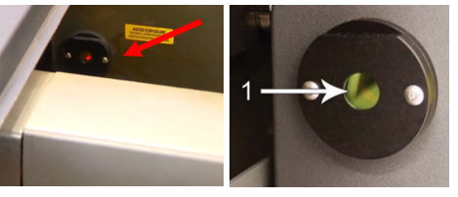
Beam Window

The Beam Window is where the beam enters into the processing area. It is labeled 1 in the graphic and is located in the upper left side of the machine’s cavity behind the left side of the gantry (see red arrow). It is only necessary to clean the front side of the beam window. Clean it when it appears dirty with the cleaning method described on Page 51. Do not remove the beam window—leave it in place as you clean it.

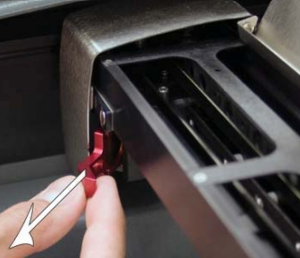
Handled Mirror

After the laser beam enters through the beam window it passes through the handled mirror. To gain access to the handled mirror, flip the X-axis rail cover up and out of the way. Locate the mirror’s red handle on the left end of the rail and gently slide it out of the holder. It is held in place by magnets so you may feel a slight resistance as you are sliding it out.
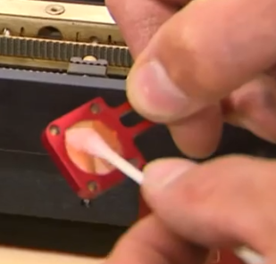

Inspect the handled mirror and clean it only if there is debris present. To clean the handled mirror, use the cleaning method described on Page 51 on either or both sides that appear dirty.

Reinstall the mirror by sliding it back into its holder until seated. When reinstalling the mirror do not install it backwards—the bend in the handle protrudes to the front.
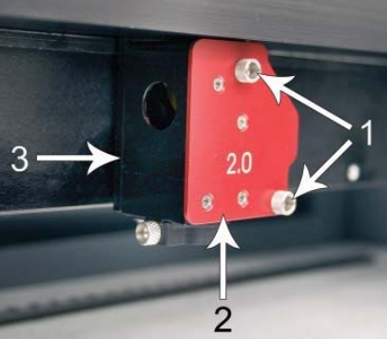
Mirror and Focus Lens Combo

After the handled mirror turns the laser beam, it passes to the mirror and then the focus lens in the “mirror/focus lens combo assembly. To get to the Mirror and Focus Lens that are hidden behind the red Front Cover Plate, you will want to start by doing two precautionary steps before proceeding to steps 3 and 4.

1) Place a board or notebook on the table under the Focus Carriage (to catch anything that might fall).

2) Then “raise” the bed by pressing down on the up arrow on the machine (to decrease the “drop distance should you accidently drop the cover plate with its attached optics).

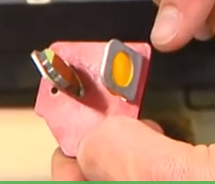
3) Loosen the two thumbscrews (marked “1” in the above graphic). They are held captive by retaining clips so they should remain with the cover. Grasp the Front Cover Plate (marked “2” in the above graphic). Gently slide it forward and out of the Focus Carriage (marked “3” in the above graphic).

4) Inspect both the Mirror and the Focus Lens and clean if they do not look clean. Be sure to inspect both the top and bottom of the Focus Lens. Use the cleaning method described on Page 51 for both the mirror and the focus lens. Make sure to use a fresh swab for each pass. Replace the red Cover Plate and tighten the thumbscrews.

Cooling Fan Filters

Although we tend to consider the BOFA Filtration System that is attached to the laser cutter with hoses as the system’s main filtration system, the Universal Laser Cutter machine has some filters that will need attention on occasion. There is a side cooling fan filter (marked “1” in the graphic below) and a rear cooling fan filter located inside the Rear Cover of the Laser Cutter Machine (marked “2” in the graphic below).

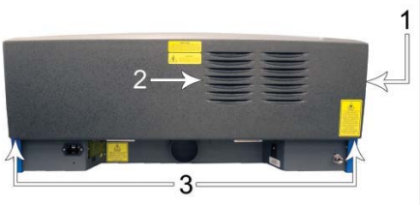
To access these filters, remove the two mounting screws (marked “3” in the graphic below) underneath the rear of the system. Lift the cover straight up and off. Locate the filters on the inside of the rear cover and on the inside of the side vent panel. Remove the plastic retainers and the filter media. Rinse the filter media with soap and water. Allow them fully dry before re-installing so you may be without a laser for 24 hours.

Maintenance of Mesh Cutting Table

When in use, material from the cutting process may fall through the honeycomb surface and collect in the bottom of the cutting table. Periodically check this area and remove any material that has collected there. The build-up of scrap material can be a fire hazard.

The honeycomb material that makes up the support surface for materials being cut will wear out over time and can easily be replaced. New honeycomb that you can swap out of that table can be purchased from Universal Laser Systems.

Maintenance Schedule

The manufacturer recommends the following schedule:

As necessary
• Clean engraving table
• Clean cutting table (emptying debris that may have fallen into the mesh)
• Clean main enclosure
• Clean top door window

Every 8 hours of engraving
• Clean X-Axis and Y-Axis bearings
• Clean X-Axis and Y-Axis rails and bearing tracks
• Clean X-Axis belt
• Check beam window, handled mirror, and mirror and Focus lens for debris. Clean ONLY if dirty.

Every month
• Clean cooling fan filters
• Clean Z-Axis lead screws with white lithium grease (same grease you should have on hand for your button maker)
• Check for X-Axis and Y-Axis belt wear.

Replace as necessary.
• Check and/or clean X-Axis and Y-Axis drive gears
• Check for X-Axis and Y-Axis bearing wear. Replace as necessary.
• Inspect system for loose screws and mechanical parts. Tighten as necessary.

Every 6 months
• Clean exhaust plenum

Additional Maintenance Information Resources

For additional information on how to maintain your Universal Laser machine related to the subjects below, see the Manufacturer’s Instructions Manual at: http://nlc.nebraska.gov/grants/InnovationStudios/Documents/vls_laser_cutter_manual.pdf

Motion System Cleaning and Maintenance
Main Enclosure Maintenance
Optics Maintenance
Rear Cooling Fan Filter Maintenance
Exhaust Plenum Maintenance
Adjustments and Lubrication

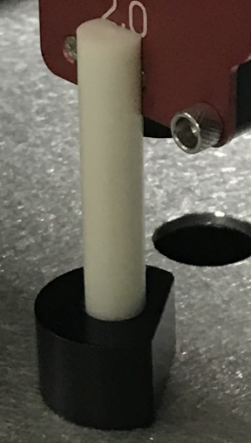
Focusing the Laser Cutter

(Occasionally the laser will become out of focus and the focal distance may need to be adjusted. This can occur when the machine is being moved around or when the tables/fixtures are swapped in and out often. Here are instructions that were borrowed from the manufacturer’s manual.)

Once you have positioned the material, you will need to focus the laser system by adjusting the Z-axis up or down until the top surface of the material to be laser processed is at the focal plane of the lens installed in the laser system. This can be done in one of three ways.
Focus Tool with Flat, Notched End Placed Up against Front Cover Plate of Lens/Mirror Assembly

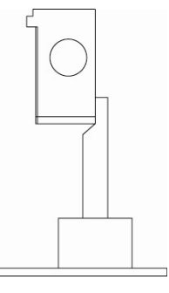
The first focusing method is to use the calibrated focus tool that came with the machine.

Manual focusing steps:

1. Manually move the focus carriage out over the material to be laser processed.

2. Move the engraving table manually up or down in the Z axis as necessary until the base of the focus tool can be placed on the top surface of the material to be laser processed and the wedge shaped notch at the top of the focus tool can be placed as shown with the edge of the carriage fitting in the corner of the notch. Laser processing results are very sensitive to focus so pay close attention to the fit of the focus tool.
Side view of Focus Tool up properly to red “Lens/Mirror Assembly” front red plate marked 2.0

3. Remove the focus tool from the material processing area.

A second focusing method is to measure the thickness of the material (use calipers for accuracy) to be laser processed and manually move the Z-axis up or down until the Z axis position equals the measured thickness.

Important Note: Make sure the lens specified in the system tab of the UCP matches the lens installed in the laser system when using this method. The lens in the machine will have a number of the front bracket (probably marked 2.0).

CAUTION: In order for this method to work correctly, the Z-axis must be properly homed and calibrated to the lens being used. To verify this, move the Z axis manually until the Z axis position reads zero and use the manual focus tool as described in the manual focus section above to verify that the surface of the engraving table is at the focus plane. If necessary, re-home the Z axis using the home Z command in the UCP viewer tab and re-check. If you are still having trouble, recalibrate the lens using the lens calibrate function in the system tab of the UCP.

A third focusing method is to measure the thickness of the material (use a calipers for accuracy) to be laser processed and enter the material thickness into the printer driver settings when printing. In materials database printer driver, you will enter the thickness in the material thickness field. With this method, the Z-axis will move up or down to the appropriate height when you press the start button to initiate laser processing of the selected job.

Important Note: Make sure the lens specified in the system tab of the UCP matches the lens installed in the laser system when using this feature and that the Auto-Z function is enabled. The lens in the machine will have a number of the front bracket (probably marked 2.0).

CAUTION: In order for this method to work correctly, the Z-axis must be properly homed and calibrated to the lens being used. To verify this, move the Z-axis manually until the Z axis position reads zero and use the manual focus tool as described in the manual focus section above to verify that the surface of the engraving table is at the focus plane. If necessary, re-home the Z axis using the home Z command in the UCP viewer tab and re-check. If you are still having trouble, recalibrate the lens using the lens calibrate function in the system tab of the UCP.

Manual Control Tab

The Manual Control Tab is generally only used by more experienced makers but if you are looking for a specific look, it can come in handy.

You will notice that there are several sliders on this tab to include Power, Speed, and PPI (Pulses per Inch).

POWER The power setting for the laser beam, ranges from 0 – 100%.
More Power = Deeper cut.
Less Power = Shallower cut

SPEED The speed of the laser head ranged from 0 – 100%.
Less Speed = Deeper cut
More Speed = Shallower cut
Note: Speeds over 15% may cause wavy cuts in small or intricate lines
DO NOT EXCEED 25% FOR VECTOR!

PPI Spacing between laser pulses
(Pulses Low PPI (0 – 150) = Perforation, not much burning
Per Inch) Medium PPI (150 - 750) = Smoother cut resolution, some burning
High PPI (750 – 1000) = Smoothest resolution, more burning

NOTE: If you make any adjustments, make sure to Apply and OK.

System Tab

The System Tab allows you to configure certain features of the laser system. If your laser system needs to be calibrated, you will need to do so from this tab. The System tab contains the following controls:
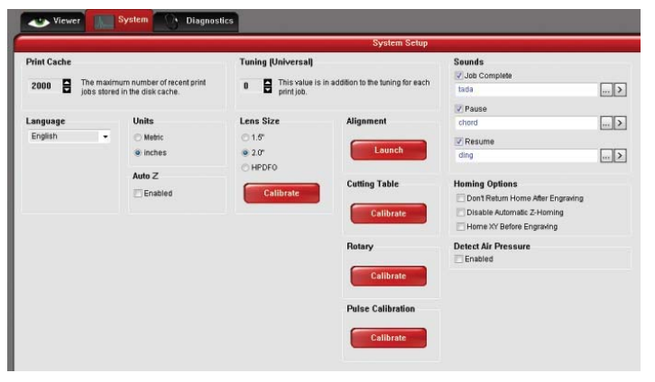
The PRINT CACHE number indicates the maximum number of print jobs that will be stored on your hard drive. If you exceed the number shown, the software will automatically begin deleting the oldest jobs as newer jobs enter the queue, unless “Permanent” is checked in the File Management window.

LANGUAGE allows you to switch between available languages according to your preference.

UNITS allows you to choose between Metric or English units of measure.

AUTO Z enables a feature that automatically moves the Z-axis to the material thickness value entered into the printer driver properties window. If it is disabled, the Z values entered in the printer driver properties window will be ignored and you will need to set focus manually by using the Focus Tool. If you use this feature, make sure the Z-axis has been properly homed.

The TUNING value is used compensate for mechanical lag when raster engraving by shifting the left to right and right to left raster lines with respect to each other by the amount entered.

The LENS SIZE selection lets the laser system know which lens you have installed. The Lens size is generally printed on the Red front plate that the lens is attached to. This is important for proper function of the auto Z mode in the laser system and auto-focus feature in those laser systems with autofocus. Lenses are calibrated to the laser system at the factory, but if you replace a lens you will need to recalibrate the lens. Select the Calibrate feature and follow the instructions given.

The ALIGNMENT Mode Launch button opens the Alignment Mode window for checking and adjusting alignment of the laser to the motion system. The Alignment feature should only be used if instructed by the Customer Service Team at ULS.

CUTTING TABLE allows you to calibrate the Z-axis to the top surface of a removable cutting table. You need to have the cutting table installed in the system to activate the CALIBRATE button. To calibrate, press the button and follow the instructions.

ROTARY allows you to calibrate the Z-axis to a rotary fixture. You need to have the rotary fixture installed in the system to activate the CALIBRATE button. To calibrate, press the button and follow the instructions.

PULSE CALIBRATION is set at the factory to calibrate laser pulsing for the installed laser. It should not be adjusted unless you are instructed to do so by the Customer Service Team at ULS.

If the SOUNDS box is checked, the computer will play the sound file selected every time the selected event occurs. You can attach sounds to the JOB COMPLETE, PAUSE and RESUME events.

HOMING OPTIONS allows you to change behavior of the homing features in the laser system. By default, after a job is complete the motion system will return home. To prevent this, select the ‘Don’t Return Home After Engraving’ switch.

If the laser loses its Z location, the materials processing table will home at start-up. To have this feature turned off, check the ‘Disable Automatic Z-Homing’ switch. Disabling this feature can also be helpful when troubleshooting Z-Axis problems.

If you would like the laser system to re-home the X and Y axes before it processes each job, select the ‘Home XY Before Engraving’ switch.

Diagnostics Tab

The Diagnostics Tab gives you important information about your laser system for troubleshooting purposes. The diagnostics tab contains the following:
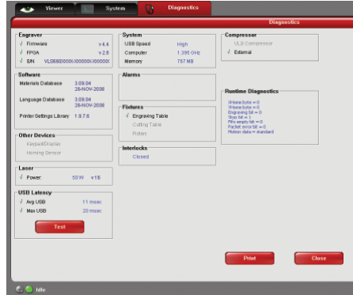
ENGRAVER shows the current Firmware and FPGA version being loaded in the laser system. It also displays the Serial Number of your laser system. The Serial Number is needed when calling the Customer Service Team at ULS.

• SOFTWARE displays the current Materials Database, Language Database and Printer driver versions being used.

• OTHER DEVICES displays the current firmware version for various devices installed in the laser system as well as status information about those devices.

• LASER displays information about the current laser cartridge(s) installed in the laser system. If a red ‘x’ appears, this indicates that the laser cartridge is either not functioning properly or is disabled because one of the safety interlocked doors to the laser system is open (causing the interlock system to disable the laser).

• The Test button, under USB LATENCY, displays information about the speed of the USB connection. Typical USB 2.0 performance should be below 10 msec and worst case USB 2.0 performance should be below 100 msec.

• SYSTEM displays information about your personal computer.

• ALARMS shows the status of the over-temperate circuit in the material processing area and indicates if the Thermal Sensor circuit battery is low in power. If the Thermal Sensor inside the laser system is triggered, an alarm will sound and the laser will be shut down.

• FIXTURES indicates if a cutting table is installed on the engraving table and properly detected.

• INTERLOCKS displays the status of the Top, Front or Rear Doors of the laser system.

• COMPRESSOR shows the status of the ULS Computer Controlled Compressed Air Unit which supplies compressed air for the air assist feature.

• The RUNTIME DIAGNOSTICS box for use when troubleshooting.

• The PRINT button gathers the information displayed on the Diagnostics Tab into a PDF file. This PDF file can be emailed to the ULS Customer Service Team for aid in troubleshooting.

BOFA Filtration System—Changing Filters

First identify what make and model of filtration system is attached to your laser cutter. The instructions here are specific to the BOFA AD Base C180 filtration system.

Much of the information concerning reading the light indicators can be found on Page 15. If the lights are Green, everything is good. If the light changes to Amber, one of the filters is at least three-fourths full so you should make sure you have replacement filters (one of each) in stock. If the Red Light is on, one of the filters is full and you can no longer operate the laser cutter unless you swap out one of the two filters.

In this BOFA system, there are two filters, the Pre Filter (sometimes called Bag Filter) and the Combined Filter. It is possible that only the pre filter/bag filter is full as that one generally fills up first. However, when the Combined Filter is full, it is best to change both filters (according to the BOFA’s manual).

So how do you know which filter to change--the pre filter, the combined filter or both?

First swap out the pre filter bag. Once installed, check to see if you get a green light. If all is well, you can use the laser and set aside the unused new combined filter until it is needed in the future. Take care to keep track of your replacement filters—these are expensive. If the light is still red, replace the combined filter as well. An indicator of the combined filter being at its end of life is odor. If you cut a piece of wood and the odor is strong, it is time to think about replacing this filter.

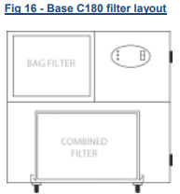
After a new filter is successfully swapped out, place the old full filter in the empty box that the new filter came in and seal the box so that dust does not escape needlessly. Simply dispose the box with the used filter in the trash bin (unless you suspect that you may have changed the ‘less filled’ filter in which case you could keep it around for a short time).

Instructions to change one or both filters associated with the C180 model:

Bag/Pre-Filter Replacement:

- Unplug the filtration unit.
- Undo the doorknobs by turning them 90 degrees and open the door.
- The bag/pre-filter is the top filter. Slide the pre filter tray outwards.
- Remove the two locating lugs by the bag filter inlet, undo the two Velcro straps and separate the bag filter from the tray.
- Replace with new bag filter ensuring the Velcro straps are secured.
- Press the locating lugs into place at the bag filter inlet, slide the tray into place. Close door, turn door latches, and reconnect the power supply.

Combined Filter Replacement:

- Unplug the filtration unit
- Undo the doorknobs by turning 90 degrees and open the door.
- The combined filter is the lower filter.
- Undo the clips on either side of the filter and carefully remove the combined filter from the unit.
- Replace with new combined filter and secure it with the clips removed earlier.
- Close door, turn door latches, and reconnect the power supply.

IMPORTANT NOTE: When one of the Library Innovation Studio host libraries changed out the bag filter, somehow it was pushed aside when they closed the BOFA door. This shifted bag filter led to the red right returning in a few weeks because the new filter really was not able to do its job. So be careful when installing the filter and closing the machine back up. However, a person with average mechanical skills should be able to change these filters if they read and follow the instructions. Following the instructions should give you a proper installation.

Filters for C180 System (the one that serves as a base for the laser cutter) | Filters for smaller AD360 System
A1030050 - Combined Filter C180 | A1030056 - Pre Filter AD350
A1030077 – Pre Filter C180 | A1030055 - Combined Filter AD350

