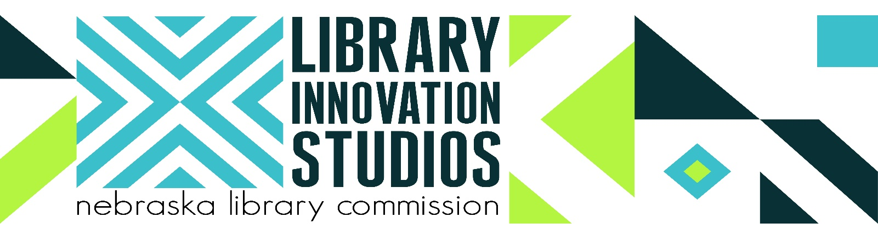

Library Innovation Studio Makerspace at [Library Name] Public Library

What: [Library Name] Public Library Open House
When: DATE, TIME p.m.—remarks at TIME.
Where: [Library Name] Public Library, ADDRESS
Who: Local Contact: [Library director, phone, e-mail]
Local Partners: [Specify]
Nebraska Library Commission Contact: JoAnn McManus, 402-471-4870, joann.mcmanus@nebraska.gov

Why:
[Library Name] Public Library is collaborating with the Library Innovation Studios: Transforming Rural Communities project to host a rotating Makerspace in the library. This learning environment will provide the opportunity for adults and young people to access technology and stimulate creativity, innovation, and the exchange of ideas to facilitate entrepreneurship, skill development, and local economic development. [Community Name] is partnering with the Nebraska Library Commission, University of Nebraska-Lincoln, Nebraska Innovation Studio, Nebraska Extension, and Regional Library Systems to help enable collaborative community development efforts that bring together local libraries, extension educators, 4-H youth development specialists, business leaders, development professionals and volunteers, community organizations, educators, and other community stakeholders to take charge of the community they want to build—and to experiment with using a library Makerspace to help build it.

[Add local quotes from Community Action Team and Training Team members and stories here from potential Makers here!]

What:
[Library Name] Library Innovation Studio will receive equipment during a [eighteen, nineteen or twenty-week] hosting period, including components from the following:
- Digital fabrication (3D printer, laser cutter, vinyl cutter, CNC router)
- Electronics (prototype kits, microcontrollers, robotics)
- Textiles (heat press, embroidery/sewing machine)
- Digital media creation (filmmaking/digital photography)
- Music technology
- Specialized software, button maker, laminator & basic hand tools

Project Background:
A National Leadership Grant of $530,732 awarded by the Institute of Museum and Library Services (IMLS) to the Nebraska Library Commission supports this partnership effort.

“This partnership demonstrates how our Nebraska communities can use technology and education to empower community residents to create, learn, and invent,” said Governor Ricketts when launching the project this fall. “By expanding the skills of the workforce in our communities, supporting entrepreneurs, and encouraging lifelong learning, this partnership reinforces our vibrant business climate and supports community development.”
“Nebraska’s public libraries are the natural gathering points for people to come together to share materials, knowledge, and experiences,” said Nebraska Library Commission Director Rod Wagner. “Whether the materials and tools are high tech or low tech, digital or analog, art or science, the focus is to create, invent, tinker, explore, and discover using the tools, materials, and knowledge available. Libraries have always been dedicated to community partnership, collaboration, and the free exchange of ideas—Makerspaces are the next step in that progression.”
“UNL and Nebraska Innovation Studio are extremely excited to be partnering with the Nebraska Library Commission and libraries across the State of Nebraska to help bring hands-on learning experiences to Nebraskans of all ages,” said UNL Nebraska Innovation Studio Founder Shane Farritor. “I think it is very important to provide the opportunity to be creative and this partnership is going to create new opportunities.”
Partners:
As Nebraska’s state library agency, the Nebraska Library Commission is an advocate for the library and information needs of all Nebraskans. The mission of the Library Commission is statewide promotion, development, and coordination of library and information services—“bringing together people and information.” The most up-to-date news releases from the Nebraska Library Commission are always available on the Library Commission website, nlc.nebraska.gov (search on News Releases).

The Nebraska Innovation Studio (NIS)—the UNL Makerspace—is the creative and collaborative hub of UNL’s Nebraska Innovation Campus, where Makers and builders team up to conceptualize, prototype, and iterate projects that solve problems and influence change. The primary focus is on creativity, interdisciplinary collaboration, entrepreneurship, and education.

Nebraska Extension is one of three components of the University of Nebraska-Lincoln’s land-grant mission. It is a dynamic educational organization that puts research to work in local communities, businesses, and individuals’ lives. Extension professionals are recognized for subject matter competence, excellent teaching skills, and community presence. They live and work in Nebraska communities across the state and engage with local and state partners in educational program delivery to address critical issues identified by constituents.

Nebraska’s Regional Library Systems are four nonprofit corporations governed by boards representative of libraries and citizens in the region. Systems provide access to improved library services by facilitating cooperation among all types of libraries and media centers within the counties included in each System area.

The Institute of Museum and Library Services is celebrating its 20th Anniversary. IMLS is the primary source of federal support for the nation’s 123,000 libraries and 35,000 museums. Our mission has been to inspire libraries and museums to advance innovation, lifelong learning, and cultural and civic engagement. For the past twenty years, our grant making, policy development, and research has helped libraries and museums deliver valuable services that make it possible for communities and individuals to thrive. To learn more, visit www.imls.gov and follow us on Facebook, Twitter and Instagram. (Grant #LG-95-17-0046-17)

Local Partners:
The initial local library partners that will host one of the four rotating Makerspaces are:

Ainsworth Public Library
Ashland Public Library
Bridgeport Public Library
Broken Bow Public Library
Central City Public Library
Crete Public Library
Geneva Public Library
Loup City Public Library
Nebraska City, Morton-James Public Library
Neligh Public Library
Norfolk Public Library
North Platte Public Library
Plattsmouth Public Library
Ravenna Public Library
Scottsbluff, Lied Scottsbluff Public Library
South Sioux City Public Library
Wayne Public Library

Thirteen additional libraries will be selected in 2018 (deadline to submit is May 18, 2018) to host Makerspaces in 2019/20. This project began July 1, 2017 and will conclude June 30, 2020. For more information about the project or equipment that will be featured in the rotating Makerspaces, see http://nlc.nebraska.gov/grants/InnovationStudios.

