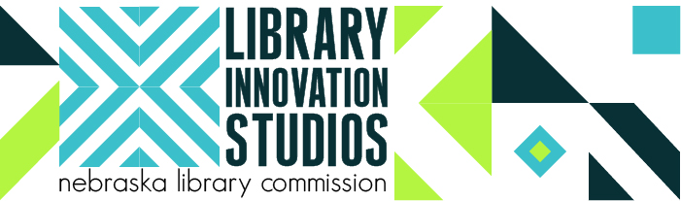

[Library Name] Public Library Hosts Library Innovation Studio Makerspace

The Nebraska Library Commission along with partners University of Nebraska-Lincoln (UNL), Nebraska Innovation Studio, Nebraska Extension, and Regional Library Systems, are collaborating with local public libraries on the Library Innovation Studios: Transforming Rural Communities project. The Nebraska Library Commission was recently awarded a National Leadership Grant of $530,732 by the Institute of Museum and Library Services (IMLS). The project began July 1, 2017 and concludes June 30, 2020.

The project uses Library Innovation Studios (Makerspaces) hosted by rural public libraries to support community engagement and participatory learning experiences by providing access to technological and innovative learning tools not readily accessible locally. This strengthening of the Maker culture in rural areas is expected to stimulate creativity, innovation, and the exchange of ideas to facilitate entrepreneurship, skill development, and local economic development.

The multi-faceted project will:
- Establish local Community Action Teams in thirty rural and small communities;
- Feature equipment and related materials for four rotating Innovation Studios;
- Develop instructional materials and user equipment certification processes;
- Employ sustainability strategies for permanent studios;
- Provide training on the use of the equipment, focusing on Train-the-Trainer strategies;
- Assist with local marketing efforts and programming/events, including Open Houses and Maker Showcases; and
- Host annual Inventors’ Fairs in Lincoln at the UNL Nebraska Innovation Studio.

These three goals guide the project:
- Rural community residents will be empowered with the tools and guidance to explore, collaborate, create, learn, and invent;
- Libraries will transform their rural communities through participatory learning spaces, while establishing themselves as strong community catalysts for community change; and
- Libraries (and communities) nationwide will have access to a replicable model.

Learn more about the project and the equipment included in the Library Innovation Studios at http://nlc.nebraska.gov/grants/InnovationStudios/

This project was made possible in part by the Institute of Museum and Library Services [grant #LG-95-17-0046-17].

Benefits for [Library Name]/[Community Name]
- Library Innovation Studio equipment for a hosting period of eighteen to twenty weeks, including components from the following categories:
  - Digital fabrication (3D printer, laser cutter, vinyl cutter, CNC router);
  - Electronics (prototype kits, microcontrollers, robotics);
  - Textiles (heat press, embroidery/sewing machine);
  - Digital media creation (filmmaking/digital photography);
  - Music technology; and
  - Specialized software, button maker, laminator and basic hand tools.
- Opportunity for the community to see the benefits of a Makerspace.
- Train-the-Trainer sessions at Nebraska Innovation Studio and locally.
- Troubleshooting videos, instructions, and access to project staff (virtually and in-person).
- Assistance with community engagement process and local programming and events.
- Annual Inventors Fair in Lincoln following the library’s hosting period.
- Access to project staff including Nebraska Library Commission, Nebraska Extension, and Nebraska Innovation Studio.
- Connection to a network of Makerspaces and Nebraska Innovation Studio.
- Eligibility to receive one or more pieces of studio equipment at the end of the project.

Expectations of [Library Name]/[Community Name]
- Organize a Community Action Team and conduct Community Engagement activities that will engage local organizations, get buy-in, and identify volunteers.
- Identify staff and recruit Training Team volunteers (5 or more) for two Train-the-Trainer opportunities.
- Prepare space for installation of equipment including tables, carts, and/or counters to hold the components and tables and chairs for groups working together on projects.
- Market the Library Innovation Studio prior to and during the hosting period, including hold an Open House, hold a Maker Showcase, conduct outreach visits to community groups, and distribute promotional materials to target audiences.
- Make studio components available to the public on a regular basis.
- Schedule open studio hours, local training and user equipment certification sessions, and regular weekly programming hours to feature particular content areas.
- Assist users with equipment certification, enter new certifications into the database, and verify users are certified to operate equipment (applies to select components only).
- Encourage users to showcase their creations/inventions at the annual Inventors Fair.
- Collect evaluation information and surveys from participants during activities.
- Work with the Community Action Team to secure/maintain Makerspace equipment in the community AND/OR use the Community Engagement process to work with community partners on other initiatives related to library services to meet community needs.

For more information contact [Library Name] Public Library,[ ADDRESS], [Library director, phone, e-mail].

